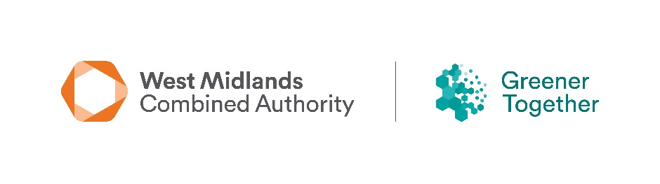

**West Midlands Combined Authority**

**future community-led environment projects**

**Survey Form**

The WMCA are looking to better understand the types of projects that may be seeking grant support in the future; like those from the [Community Green Grants](https://www.wmca.org.uk/what-we-do/environment-energy/community-green-grants/) and [Community Environment Fund](https://www.wmca.org.uk/what-we-do/environment-energy/community-environment-fund/) programmes. To help us, we would like to collect project ideas, and to see what type of grant help you may need to deliver your future project.

***Please note that all awards for the WMCA Community Environment Fund and Community Green Grants have been made now, and completion of this form does not act as part of an application for grant funding or guarantee that you will receive funding from WMCA in the future.***

|  |
| --- |
| **Which of the following themes would your project relate to.** |
| Natural environment  Access to green/blue space  Climate adaptation  Circular economy  Environment awareness  Air Quality  Other (please state) |

|  |
| --- |
| **Briefly describe the overall aim and objectives of your project including how the environment and community would benefit.** |
|  |

**continued**

|  |  |
| --- | --- |
| **If you think that you would need a grant to help you deliver your project, please provide the following information:** | |
| **Organisation Name** |  |
| **Organisation Type** |  |
| Project Name |  |
| **Estimate amount (£’s) required** |  |
| **Project location (include a post code)** |  |

|  |
| --- |
| **Contact Name:** |
|  |
| **Contact Email:** | |
|  | |
| **Contact Tel:** | |
|  | |

**Once complete, please email to environment@wmca.org.uk**