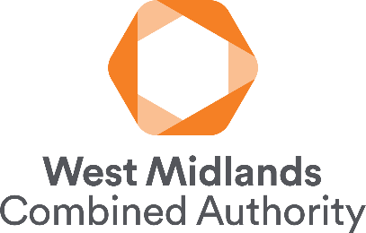
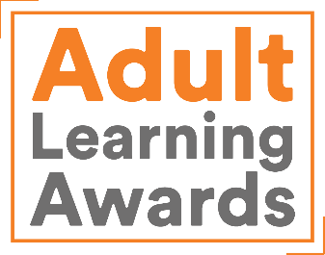

Nominating an individual learner: Guidance notes
All nominations must be submitted online.

Contents
About West Midlands Adult Learning Awards 1
Guidance notes and eligibility criteria 2
How to submit a nomination 3

About West Midlands Adult Learning Awards
The West Midlands Adult Learning Awards seek to recognise and celebrate the achievements of adult learners, businesses, providers and wider partners across the West Midlands Combined Authority (WMCA) area. Through these awards, we are looking to:
- Raise the profile of adult learning across the region
- Engage more residents, businesses and wider stakeholders in adult learning
- Capture and celebrate good practice in adult learning across the region
- Showcase the full range of economic and social benefits of adult learning
- Demonstrate the impact of skills devolution, enabling us to make the case for further devolution.
Award winners are selected for a range of awards across four nomination categories:
- Individual learner
- Tutor
- Employer
- Learning provision (includes learning providers and partnerships)

Why nominate?
By nominating an individual learner, provider, tutor or employer you can celebrate their successes. Providers and employers can showcase their work and use it for both recruitment and reputation purposes. Individuals could showcase it on their CVs or LinkedIn profiles to highlight their commitment to professional development and learning.

Selection of award winners – key dates
- All nominations must be submitted by Friday 2 February 2024 at 12.00 noon GMT.
- Winners will be selected in March 2024.
- Winners and their nominators will be notified by 31 March 2024.
- Nominators of non-winners will be sent a certificate of achievement to present to their nominee.
- Winners will be announced on 27 June 2024.
The deadline for nominations is final and there will be no extensions provided.
If you haven’t heard from us by the end of March 2024, please assume that your nominee has not been selected as an award winner on this occasion. The decisions of the selection panel are final.

Guidance notes and eligibility criteria
Individual learners will:
- Be learning to improve their skills to improve their employment prospects, for personal development, for health and wellbeing (physical or mental) or to benefit their family or community.
- Illustrate the transformational power of learning as an adult.
- Show significant evidence of how their learning experience has changed their life, for example improved their employment prospects, opened new opportunities, or had an impact on their family, friends, colleagues or community.
- Have made significant in-roads into their learning journey and wish to continue to learn.
- Have participated in adult learning provision funded by WMCA. This can include SWAP/gateway provision, Skills Bootcamps, or adult learning funded through Community Learning funding, Adult Education Budget (AEB), Free Courses for Jobs, Multiply.
- Help to make a strong case for the devolution of skills funding through advocacy and media activity.
- Be inspiring to other learners.

Inspirational Adult Learner award
We’re looking for a standout individual who has been on a transformational learning journey, and who has shown enthusiasm for continued learning. We want to recognise that learning isn’t restricted to the classroom. We are looking for learners who could motivate others to take up learning, especially those who lack the confidence to do so.

Learning for Work award
We’re looking for an individual who has improved their employment prospects in their current role, undertaken upskilling or retraining, secured a new job, set up a business or progressed at work as a result of their learning. Examples include CPD, workplace training, improving existing skills in a current job, accessing training to take on a new role or to secure a new job, changing career or setting up a business. (Please note apprenticeships are not eligible for this award)

Apprentice award
We are looking for an individual who has started or completed an apprenticeship funded through the WMCA apprenticeship levy transfer fund. We are looking for apprentices who have made a real difference to their workplace and used an apprenticeship to boost their career.

Step into Learning award
We are looking for an individual who has recently returned to learning and whose story demonstrate the benefits learning can have on individuals and their families right from the outset. The winner may have returned to learning to improve basic skills such as English, maths and digital skills, or to gain confidence and build self-esteem. The winner will inspire and motivate others to take a first step into learning as an adult – especially those who have not been engaged in learning for many years.

How to submit a nomination
Please read through the following guidance carefully.
- The awards nominations process is online.
- Nominations should be submitted online by the nominator.
- One form should be completed per nominee.
- There are four different online nomination forms for:
- Individual learners
- Tutors
- Learning provision
- Employers
- Based on the information provided, nominations for individual learners will be considered for all relevant awards.
- Nominations for individual learners are open to learners whose learning took place in England only and who are aged 18 or over on 1 February 2024.
- Nominations for individual learners will need to include written statements from the nominee. It is the nominator’s responsibility to explain the nominations process to the nominee and obtain the relevant written statements from the nominee for inclusion in their nomination.
- The online nomination form needs to be completed in one sitting. You cannot save a partially completed nomination form and return to it later. Therefore, we strongly advise you to prepare and draft your nomination using the nomination questions form document in advance.
- It is possible to submit multiple nominations. Once one nomination has been completed and submitted online, you will be able to begin the form again to start a new nomination.

Preparing and drafting nominations
The questions within the individual learner nomination form are provided a separate form to help you prepare and draft your nomination. We recommend that you use this document to do this for the following reasons:
- It will enable you to review all questions on the nomination form before completing any answers. The online nomination form requires you to complete one section before you can move on to view the next.
- You will be able to work on your nomination form without being connected to the internet. An internet connection is required to work on the online nomination form.
- Should you encounter any technical issues with the online form, you will still have a saved copy of your work in a Word document.
- To keep a copy of your final nomination for your own records. Once your nomination has been submitted, you will no longer be able to access it online.
When you are happy with your nomination, complete the online form by copying answers from each box from your pre-prepared Word version into the relevant boxes of the online nomination form. We cannot accept nomination forms that are sent to us using the Word document. It has been provided to help you to draft your nomination only.

Technical or accessibility issues and other support
If you have any questions about the nominations process or are unable to complete the online nominations form due to technical or accessibility issues, please contact westmidawards@learningandwork.org.uk
We will respond to emails as soon as possible (usually within two working days).

