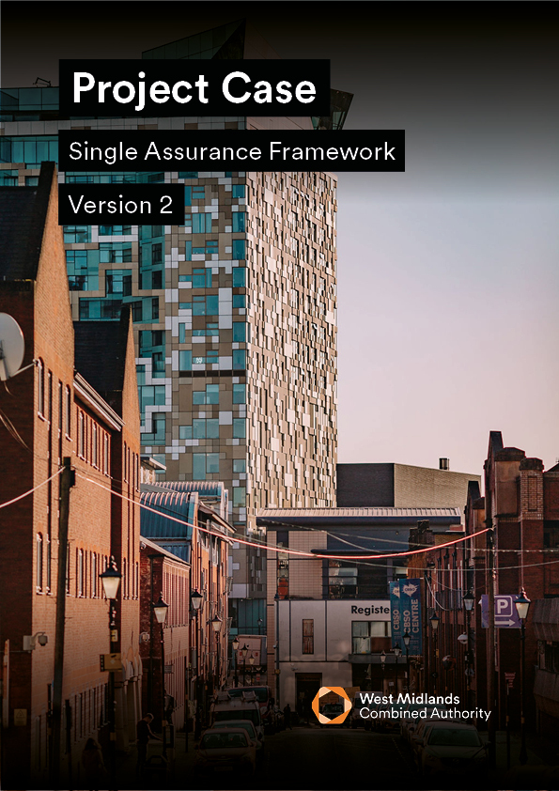

<INSERT PROJECT NAME>

# ­­­project case VERSION 2.1

The purpose of this document is to provide a simplified business case listing project details, where a project is being delivered under a Programme Business Case.

A Project Case is only appropriate in the following circumstances:

* Project outputs and outcomes are covered by an existing approved Programme Business Case
* Deliverables and costs are in line with Programme averages (e.g. when measured in cost per unit deliverable)
* The cost of the project is under £5m

In other cases, the appropriate business case as set out in SAF should be followed. Contact the Programme Assurance and Appraisal team for advice.

## Guidance

* To support better spending, investment decisions and better procurement, this Project Case should be written using WMCA guidance, which can be found [here](https://www.wmca.org.uk/media/miifhus4/wmca-saf-gd021-project-case-guidance-v2-1.pdf).
* In addition, it is a requirement that all proposals for public funds submitted to WMCA are guided and based around the HM Treasury’s Green Book and supporting information can be found [here](https://www.gov.uk/government/publications/the-green-book-appraisal-and-evaluation-in-central-governent/the-green-book-2020?msclkid=e4ea50b2c56a11ec815238da40854bb6).
* The input of key stakeholders must be detailed within Table 2, or the business case will be rejected until this information is provided.
* Mandatory appendices as listed in Section 6.0 of this business case must be submitted as supplementary documents.

|  |  |  |  |  |
| --- | --- | --- | --- | --- |
| *Table 1* | | | | |
| **PROJECT DETAIL** | | | | |
| **Project Name:** | |  | | |
| **Programme Business Case Name:** | |  | | |
| **WMCA Directorate:** | |  | | |
| **Delivery Team (if WMCA internal):** | |  | | |
| **Organisation (if WMCA external):** | |  | | |
| **GOVERNANCE** | |  | | |
| **If external to WMCA, when was this project approved by your internal governance?** | |  | | |
| **VERSION CONTROL** | | | | |
| **Version:** |  | | **Date:** |  |
| **PC Prepared by:** |  | | **Job Title:** |  |

|  |  |  |  |  |
| --- | --- | --- | --- | --- |
| *Table 2* | | | | |
| **STAKEHOLDER INVOLVEMENT**  Please provide the names and level of input of the stakeholders listed below.  Note that some are mandatory and others are optional / dependent on the source of funding / nature of the project, this is made clear on the left of the table below. | | | | |
|  | **Role** | **Name** | **Input** | **Date** |
| **Mandatory** | **Senior Responsible Owner (SRO):** |  | Choose an item. |  |
| **WMCA Executive Director:** |  | Choose an item. |  |
| **Finance Lead:** |  | Choose an item. |  |
| **Legal Representative:** |  | Choose an item. |  |
| **Procurement Lead:** |  | Choose an item. |  |
| [**Digital and Data Engagement and Delivery**](mailto:DigitalandDataEngagementandDeliveryTeam@wmca.org.uk)**:**  ***(if WMCA internal)*** |  | Choose an item. |  |
| **Optional** | **Programme SRO:**  ***(if applicable)*** |  | Choose an item. |  |
| [**Major Programme Finance**](mailto:majorprogrammereturns@wmca.org.uk)**:**  ***(if CRSTS/ Investment Programme funded)*** |  | Choose an item. |  |
| **Human Resources:** |  | Choose an item. |  |
| [**Transport Planning** **Assurance**](mailto:Transport%20Planning%20Assurance%20%3cTransportPlanningAssurance@tfwm.org.uk%3e)**:**  ***(if CRSTS funded)*** |  | Choose an item. |  |
| [**Cycling Team**](mailto:cycling@tfwm.org.uk)**:** |  | Choose an item. |  |
| [**Network Mitigations Forum**](mailto:behaviourchangehub@tfwm.org.uk;colin.whitehouse@tfwm.org.uk)**:** |  | Choose an item. |  |
| [**Inclusive Growth Team**](mailto:InclusiveGrowthUnit@wmca.org.uk)**:** |  | Choose an item. |  |

## finance summary

|  |  |
| --- | --- |
| *Table 3* | |
| **Finance Summary** | **Project Case (£)** |
| **Total Project Cost:** |  |
| **WMCA Funding Requested:** |  |
| **WMCA Funding Stream:** |  |
| **Funds Secured:** |  |
| **Funds Not Secured:** |  |

# 1 - strategic case

# *providing strategic fit supporTED BY A COMPELLING CASE FOR CHANGE*

## 1.1 project summary

Please provide a one-page stand-alone summary of the project which includes a description of the project’s location and its relation to the programme. Note there is no need to repeat details of the wider programme, but please provide a reference to evidence how this specfic project contributes to the programme and WMCA’s business strategy and why there is a gap in the market that needs to be filled. This summary should include but not be limited to:

* Project Description
* Target Objectives
* Associated Outputs

## 1.2 Project Spending Objectives and Alignment to Programme

Show how this project will contribute to each of the objectives in the Programme Business Case. Objectives and associated outcomes should be based on SMART methodology (Specific, Measurable, Achievable, Realistic and Time-dependent). Targets should be related to these objectives along with the current baseline measure.

Note, all projects need to consider Inclusive Growth and its contribution to Net Zero.

|  |  |  |  |  |  |  |
| --- | --- | --- | --- | --- | --- | --- |
| *Table 4* | | | | | | |
| **#** | **Objective** | **Quantitative Baseline** | **Target** | **Project Contribution** | **Project Outputs** | **Alignment to WMCA Aims and Objectives** |
| **1.** |  |  |  |  |  | Choose an item. |
| **2.** |  |  |  |  |  | Choose an item. |
| **3.** |  |  |  |  |  | Choose an item. |
| **4.** |  |  |  |  |  | Choose an item. |
| **5.** |  |  |  |  |  | Choose an item. |
| **6.** |  |  |  |  |  | Choose an item. |

# 2 - Economic case

# *Maximising public value to society through the selection of the optimal combination of scope, costs and outcomes*

## 2.1 key risks

Specify the key risks associated with the achievement of the project’s objectives, along with the key activity aimed at either managing the cause or mitigating the effects of each risk.

The information provided should be an extract from the Risk Register and Issue Log attached with this PC.

|  |  |  |  |  |  |  |
| --- | --- | --- | --- | --- | --- | --- |
| *Table 5* | | | | | | |
| **ID** | **Risk** | **Impact**  **(1-5)** | **Probability**  **(1-5)** | **RAG**  **Rating** | **Risk**  **Owner** | **Mitigation** |
|  |  |  |  |  |  |  |
|  |  |  |  |  |  |  |
|  |  |  |  |  |  |  |
|  |  |  |  |  |  |  |
|  |  |  |  |  |  |  |

## 2.2 Options analysis and appraisal

Please identify a minimum of 4 options and complete a shortlisting exercise within the table below; options must include ‘BAU/Do Nothing’ and ‘Do Minimum’.

|  |  |  |  |  |  |
| --- | --- | --- | --- | --- | --- |
| *Table 6* | | | | | |
| **Option Label** | **Business as**  **Usual**  **(baseline)** | **Do-minimum**  **Option** | **Preferred**  **Way Forward**  **(if not Do-**  **Minimum)** | **More ambitious preferred way forward** | **Less ambitious preferred way forward** |
| Description of Option |  |  |  |  |  |
| Appropriate BCR |  |  |  |  |  |
| Significant Quantified but unmonetizable benefits |  |  |  |  |  |
| Significant unquantifiable benefits |  |  |  |  |  |
| Meets Objectives (Y/N) |  |  |  |  |  |
| Shortlisted (S) / Rejected (R) |  |  |  |  |  |

## 2.3 Value for money assessment

Complete Table 7 below to provide decision-makers with a summative VfM assessment:

|  |  |
| --- | --- |
| *Table 7* | |
| **Social Benefits and Costs**  (with range) |  |
| **Whole-Life public sector costs of preferred option (£m)** |  |
| **Value for Money judgement**  (why is this option being chosen over others) |  |

Provide quantified benefits for the following items. Note that inclusion here is independent of the social benefits and BCR calculation, and not all items should be included in a Green Book appraisal

|  |  |  |
| --- | --- | --- |
| *Table 8* | | |
| **Item** | **Quantified benefit** | **Social benefit included in BCR** | |
| GVA | *£m increase in WM GVA over x years* | N/A | |
| Jobs created | *Number created in WM over x years* | N/A | |
| Houses built | *Number built in WM over x years* | N/A | |
| Carbon emissions | *X tonnes saved over x years* | *Valued using latest HMT values* | |
|  |  |  | |

## 2.4 Outputs and benefits

Show how this project will contribute to each of the outputs and benefits in the Programme Business Case. This table should list each of the outputs and benefits listed in the Programme Business Case and show the percentage contribution made by this project

|  |  |  |  |  |  |
| --- | --- | --- | --- | --- | --- |
| *Table 9* | | | | | |
| **#** | **Output (O) / Benefit (B)** | **Description** | **Programme Level** | **Project Level** | **Project Contribution (%)** |
| **1.** |  |  |  |  |  |
| **2.** |  |  |  |  |  |
| **3.** |  |  |  |  |  |
| **4.** |  |  |  |  |  |
| **5,** |  |  |  |  |  |

# 3 commercial case *commercially viable and attractive to the supply side*

## 3.1 procurement arrangements

Provide an overview of the procurement arrangements in place to ensure the preferred option can be delivered. This answer should explain the procurement activity carried out and set out the commercial and contractual arrangements for the negotiated deal.

State the ability of the marketplace to provide the required goods or services and the attractiveness of this proposal to potential service providers. Also include detail on how the respective procurement and legal teams have been consulted with regards to the impact of subsidy control on the project’ (including HR/IT personnel implications).

This section should include the likely drawdown timetable and security being provided for the grant.

# 4 financial case

# *affordable and fundable over time*

Unrounded figures should be used throughout the financial case

## 4.1 capital and revenue funding statement

Provide an overview of the proposed funding package to deliver the project within the table below and include the remaining funding gap (if applicable).

Insert a written summary in this section to verrify the overall affordability of the project, the line items to be funded and the funding that has been secured to date must be provided. Where there is a shortfall in available funding, provide details of how this will be addressed and the level of contingency included.

All secured funding identified below should be verified by a written confirmation attached to this PC with details of any conditions etc. Note that any funding requested via this Project Case is “unsecured” until approval of the business case.

|  |  |  |
| --- | --- | --- |
| *Table 10* | | |
|  | **Status**  ***(Secured / Not Secured )*** | **£M** |
| **Revenue** |  |  |
| **Capital** |  |  |
| **Total** |  |  |

|  |  |  |  |  |
| --- | --- | --- | --- | --- |
| *Table 11* | | | | |
| **Funder** | **Amount** | **% of Total** | **Status**  ***(Secured / Not Secured)*** | **Details of Funding Status / Timing / Conditions etc.** |
|  |  |  |  |  |
|  |  |  |  |  |
|  |  |  |  |  |
|  |  |  |  |  |
| **Total** |  |  |  |  |

## 4.2 CASHFLOW

Complete the cashflow table below setting out both income and expenditure. Amend fiscal year dates as required and number of funding sources.

|  |  |  |  |  |
| --- | --- | --- | --- | --- |
| *Table 12* | | | | |
| **Year (fiscal)** | **Q2-3**  **23-24** | **Q3-4**  **23-24** | **Q1-2**  **24-25** | **Q2-3**  **24-25** |
| **Income (£)** | | | | |
| **Revenue** |  |  |  |  |
| **Capital 1 – [state funding source]** |  |  |  |  |
| **Capital 2 - [state funding source]** |  |  |  |  |
| **Expenditure (£)** | | | | |
| **Revenue** |  |  |  |  |
| **Capital** |  |  |  |  |
| **Net position** |  |  |  |  |

# 5 management case *can be delivered successfully by the organisation and its partners*

## 5.1 management and governance

Provide an overview of the necessary management and governance arrangements both in the delivery phase and in operation i.e., include detail on:

* Governance and decision-making arrangements
* Change management arrangements (inc. reference to WMCA Change Process)
* Benefits realisation arrangements and plans, including benefits register (or MEP)
* Contract management arrangements

## 5.2 project schedule for delivery

List the key project milestones and ensure this information is fully aligned to the Project Schedule, which must be appended to this PC. Include a longstop date by which all monies for development of this PC needs to be drawn.

|  |  |  |  |
| --- | --- | --- | --- |
| *Table 13* | | | |
| **#** | **Milestone** | **Start Date** | **End Date** |
| **1.** |  |  |  |
| **2.** |  |  |  |
| **3.** |  |  |  |
| **4.** |  |  |  |
| **5.** |  |  |  |
| **6.** |  |  |  |
| **7.** |  |  |  |
| **9.** |  |  |  |
| **10.** |  |  |  |

## 5.3 MONITORING AND EVALUATION

Set out a summary of the outline Monitoring Evaluation arrangements for the project and milestones leading to Project Evaluation.

Further steer is set out within the PC guidance document and [Performance Team Intranet page](https://intranet.wmca.org.uk/section/resource-hub/finance-and-business-hub/business-improvement-team/performance-team-0). For additional support with completing the M&E template pleases contact the M&E team: [CorporateMonitoringEvaluation@wmca.org.uk](mailto:CorporateMonitoringEvaluation@wmca.org.uk)

# 6.0 mandatory APPENDICES REQUIRED FOR THIS Pc

The following documents must be appended to this PC:

|  |  |
| --- | --- |
| *Table 15* | |
| **APPENDIX** | **PROVIDED (Y/N)** |
| Benefits Realisation Plan / Monitoring and Evaluation Plan (MEP) |  |
| Benefits Register (may be contained within the MEP) |  |
| Risk Register and Issue Log |  |
| Project Schedule |  |
| Written Confirmation/s of Confirmed Funding |  |
| If CRSTS, Additional Appendix |  |