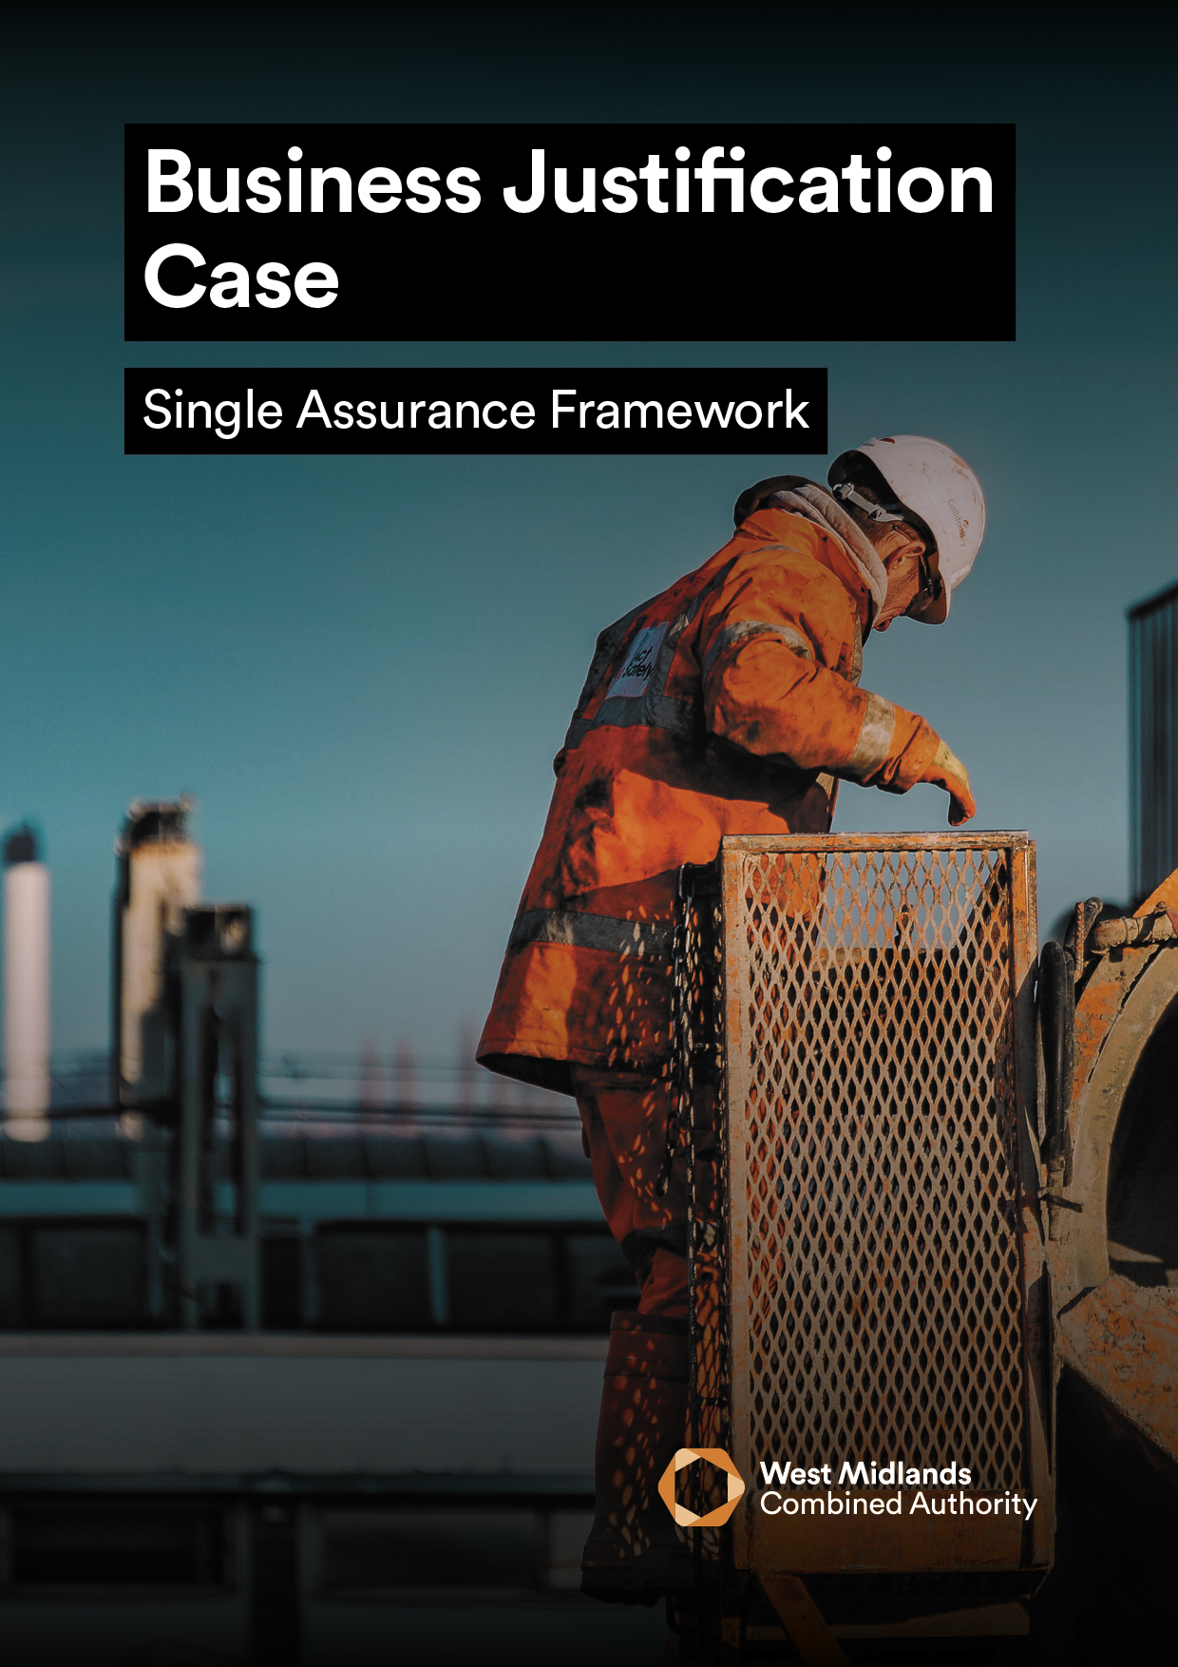
<INSERT PROJECT NAME>

BUSINESS JUSTIFICATION CASE VERSION 4.0
The purpose of the Business Justification Case (BJC) is to:
Act as a single stage business case, using the Five Case Model, for the delivery of relatively low risk spend for which firm prices are available.
A BJC may be considered within WMCA for smaller items of spend, which:
- Are not novel or contentious and
- can be procured from an existing pre-competed arrangement whilst
- recording the findings of the procurement phase to identify the option that offers the ‘most economically advantageous tender’ (MEAT) and best public value.

GUIDANCE
- To support better spending, investment decisions and better procurement, this Business Justification Case should be written using supplementary WMCA guidance, which can be found here.
- In addition, it is a requirement that all proposals for public funds submitted to WMCA are guided and based around the HM Treasury’s Green Book and supporting information can be found here.
- The input of key stakeholders must be detailed within Table 2, or the business case will be rejected until this information is provided.
- Mandatory appendices as listed in Section 6.0 of this business case must be submitted as supplementary documents.
Table 1
PROJECT DETAIL
Project Name:
Programme Name (aligned to PBC):
WMCA Directorate:
Delivery Team (if WMCA internal):
Organisation (if WMCA external):
WMCA Project Code:
GOVERNANCE
If external to WMCA, when was this project approved by your internal governance?
VERSION CONTROL
Version: |  |  | Date:
BJC Prepared by: |  |  | Job Title:

Table 2
STAKEHOLDER INVOLVEMENT
Please provide the names and level of input of the stakeholders listed below. Note that some are mandatory and others are optional / dependent on the source of funding / nature of the project, this is made clear on the left of the table below and further explained in the supplementary guidance.
 | Role | Name | Input | Date
Mandatory | Senior Responsible Owner (SRO): |  | Choose an item.
 | WMCA Executive Director: |  | Choose an item.
 | Governance Services: |  | Acknowledged
 | Finance Lead: |  | Choose an item.
 | Legal Representative: |  | Choose an item.
 | Procurement Lead: |  | Choose an item.
 | Monitoring and Evaluation: |  | Choose an item.
Optional | Programme SRO:  (if applicable) |  | Choose an item.
 | Digital and Data Engagement and Delivery:  (if WMCA internal) |  | Choose an item.
 | WMCA Finance:  e.g., Major Programme Returns (if CRSTS/ Investment Programme funded) : |  | Choose an item.
 | Human Resources: |  | Choose an item.
 | Transport Planning Assurance:  (if CRSTS funded) |  | Choose an item.
 | Cycling Team: |  | Choose an item.
 | Network Mitigations Forum: |  | Choose an item.
 | Inclusive Growth Team: |  | Choose an item.

EXECUTIVE SUMMARY

PLEASE PROVIDE A ONE-PAGE STAND-ALONE SUMMARY OF THE PROPOSED PROJECT WHICH INCLUDES (MAX 500 WORDS):

• A BRIEF PROJECT DESCRIPTION AND WHY IT IS necessary

• TARGET OBJECTIVES

• ASSOCIATED OUTPUTs

FINANCE SUMMARY

Table 3
Finance Summary | BJC (£)
Total Project Cost:
WMCA Funding Requested (within this business case):
WMCA Funding Stream:
Funds Secured:
Funds Not Secured:

1 - STRATEGIC CASE

PROVIDING STRATEGIC FIT SUPPORTED BY A COMPELLING CASE FOR CHANGE

1.1 PROJECT SPENDING OBJECTIVES AND ALIGNMENT TO WMCA AIMS
Specify the spending objectives for the project. Note, all projects need to consider Inclusive Growth and its contribution to Net Zero. These should focus on the target outcomes for the intervention and be SMART (Specific, Measurable, Achievable, Realistic and Time-Dependent). Desired outcomes include: improved economy, efficiency, effectiveness, replacement and compliance.
Table 4
# | Objective | Quantitative Baseline | Target | Specific actions and when, to achieve objective | How will the customer be impacted? (i.e. Outcomes) | Alignment to WMCA Aims and Objectives
1. |  |  |  |  |  | Choose an item.
2. |  |  |  |  |  | Choose an item.
3. |  |  |  |  |  | Choose an item.
4. |  |  |  |  |  | Choose an item.
5. |  |  |  |  |  | Choose an item.
6. |  |  |  |  |  | Choose an item.

1.2 EXISTING ARRANGEMENTS AND BUSINESS NEEDS
Provide a complete summary of the organisation’s current service model referring to its Business as Usual (BAU) offer, this may also include elements of services provided within the organisation’s external environment.
Also, state the deficiencies associated with the current provision to include demands/needs, the difference between the current provision and aspirations, through achieving project objectives. Consider the implications if the project does not proceed.

1.3 INCLUSIVE GROWTH AND EQUALITIES
Explain how this project will contribute to inclusive growth and equality within the West Midlands. If WMCA internal, the WMCA’s Inclusive Growth Framework can be found here. To add, state how health inequalities and equalities (protected characteristics as defined by the Equality Act) have been considered in the production of this business case, this can be done using the WMCA Health and Equity Impact Assessment (HEQIA) Tool found here for internal staff, or other tools available within Local Authorities. If you are external to WMCA but wish to use our HWQIA Tool, contact equalitiesteam@wmca.org.uk.

1.4 PROJECT SCOPE AND SERVICES
In order to deliver potential service improvements, it is useful to classify needs / requirements. For this project, please outline the requirements of the project based on the following hierarchy:

Table 5
The ‘Essential’ requirements

Without these requirements, the
project would not be judged to be a
success i.e. the ‘Must have’
The ‘Desirable’ requirements

The project may justify these
requirements on a value for money
basis i.e. the ‘Could have’
The ‘Optimum’ or ‘Highly
Desirable’ requirements

The project may justify these
requirements on a marginal low
cost and affordability basis i.e. the
‘Nice to have’

1.5 KEY RISKS
Specify the key risks associated with the achievement of the project’s objectives, along with the key activity aimed at either managing the cause or mitigating the effects of each risk.
The information provided should be an extract from the Risk Register and Issue Log attached with this BJC.
Table 6
ID | Risk | Impact  (1-5) | Probability  (1-5) | RAG  Rating | Risk  Owner | Mitigation

1.6 CONSTRAINTS
Specify any constraints that have been placed on the project.

1.7 DEPENDENCIES
Specify any dependencies outside the scope of the project upon which the success of the project is dependent.

2 - ECONOMIC CASE

MAXIMISE PUBLIC VALUE TO SOCIETY THROUGH THE SELECTION OF THE OPTIMAL COMBITION OF SCOPE, COSTS AND OUTCOMES

2.1 CRITICAL SUCCESS FACTORS
List the critical success factors i.e. what must this project achieve to be successful?
These are not outcomes or objectives; they are the attributes essential for successful delivery of the project.
Table 7
# | Critical Success Factor (CSF) | Alignment to Project Objectives
1.
2.
3.
4.
5.

2.2 BENEFITS APPRAISAL
Validate the main benefits associated with the achievements of the project’s spending objectives by beneficiary. Distinguish benefits from outcomes.
Table 8
# | Benefit | Benefit Classification | Beneficiary(s)
1. |  | Choose an item.
2. |  | Choose an item.
3. |  | Choose an item.
4. |  | Choose an item.
5. |  | Choose an item.

Provide quantified benefits for the following items. Note that inclusion here is independent of the social benefits and BCR calculation, and not all items should be included in a Green Book appraisal.
Table 9
Item | Quantified benefit | Social benefit included in BCR
GVA | £m increase in WM GVA over x years | N/A
Jobs created | Number created in WM over x years | N/A
Houses built | Number built in WM over x years | N/A
Carbon emissions | X tonnes saved over x years | Valued using latest HMT values

2.3 OPTIONS ANALYSIS AND APPRAISAL

Analysis - Please identify a minimum of 4 options and complete a shortlisting exercise within the table below; options must include ‘BAU/Do Nothing’ and ‘Do Minimum’. Please provide a short explanation (a couple of sentences) as to why the option doesn’t met objectives where ‘N’ is selected in the column to the right.
Table 10
Option | Description | Shortlisted (S) / Rejected (R) | Meets Objectives?  (Y/N)
1.

2.

3.

4.

Appraisal – Using the same option numbering from above, complete the following options appraisal summary.
Table 11
 | Option 1 | Option 2 | Option 3 | Option 4
Net Costs

(capital and revenue)

Benefits that arise

(monetary and non-monetary)
Risks associated

(associated with the delivery of that option)

2.4 VALUE FOR MONEY ASSESSMENT
Complete the table below to provide decision-makers with a summative Value for Money (VfM) assessment:
Table 12
Social Benefits and Costs

(with ranges)
Whole Life Public Sector Costs of Preferred Option (£m)

Value for Money Judgement

(why is this option being chosen over others?)

2.5 RECOMMENDED / PREFERRED OPTION
Confirm which option is deemed to be the Preferred Option. Conclusions should be drawn on each of the different options considered in terms of cost, benefit, risk and its ability to meet the spending objectives.

3 - COMMERCIAL CASE
COMMERCIALLY VIABLE AND ATTRACTIVE TO THE SUPPLY SIDE

3.1 EXPECTED OUTPUTS
List the goods, services and works that will be procured in relation to the recommended / preferred option within the table below:

Table 13
Output 1
Output 2
Output 3
Output 4
Output 5

3.2 ROUTE TO PROCUREMENT AND EXISTING RULES AND REGULATIONS
State the ability of the marketplace to provide the required goods or services and the attractiveness of this proposal to potential service providers.
Also include detail on how the respective procurement and legal teams have been consulted with regards to the impact of subsidy control on the project (including HR/IT personnel implications).

3.3 CHARGING MECHANISM
State how the project intends to make payment for its key services and outputs over the expected lifespan of the contract(s) and to tie down risks in the charging mechanism. Include details of the contract for the deal.

3.4 RISK APPORTIONMENT
Clarify the potential risk apportionment and identify how the service risks in the design, build, funding and operational (DBFO) phases of the project may be apportioned between the public and private sectors. The DBFO model does not just apply to capital build projects.
This should align to the Risk Register and Risk Management Strategy appended to this BJC.

4 - FINACIAL CASE

AFFORDABLE AND FUNDABLE OVER TIME
Unrounded figures should be used throughout the Financial Case. Also state how project costs have been ratified and by whom.

4.1 CAPITAL AND REVENUE FUNDING STATEMENT
A summary of the overall affordability of the project and the funding that has been secured to date must be provided.
All secured funding identified below should be verified by a written confirmation attached to this BJC with details of any conditions etc. Note that any funding requested via this BJC is “unsecured” until approval of the business case.
Table 14
 | Status  (Secured / Not Secured ) | £M
Revenue
Capital
Total

Table 15
Funder | Amount | % of Total | Status  (Secured / Not Secured) | Details of Funding Status / Timing / Conditions etc.
Total | £ | 100%

4.2 OVERVIEW OF FUNDING AND AFFORDABILITY SUMMARY
A written summary of the overall affordability of the project and the funding that has been secured to date must be provided. Where there is a shortfall in available funding, provide details of how this will be addressed, and the level of contingency included.

Complete the table below to provide an overview of WMCA funding:
Table 16
Funding Type
Grant / Cashflow (repayable) / Underwrite
Funding Commencement Date | DD/MM/YY
Funding Completion Date | DD/MM/YY
Basis of Reimbursement
Quarterly in arrears of expenditure incurred (WMCA Standard)
Any Conditions Precedent?

e.g. securing DfT funding. Include any spend deadlines, eligible spend outputs and high priority items likely to be included in any Conditional Grant offers or development agreements in principle (Heads of Terms)
Order in which WMCA Funding is to be drawn
1st/2nd/3rd

Work streams for which WMCA Funding is available to be drawn against

e.g. all / workstream 1, 3 and 4 etc.

4.3 BORROWING SUMMARY
Please state if any element of the project costs is to be financed by borrowing. (Yes/No).
If applicable please complete the following table and provide an explanation of the borrowing required to fund this project:

Table 17
Principle expected to be Borrowed | £XX
Source of Finance | (PWLB, Private, LA to LA, etc)
Loan Type | (Annuity, Equality Instalment of Principal,  Maturity, Other)
Interest Rate Assumed | X.X%
Loan Term | XX Years
Expected Loan Draw Down Date | DD/MM/YYYY
Repayment Source | (E.g. Future Customer Revenues)
Other costs Associated with Borrowing | £XX

4.4 COST BREAKDOWN
Complete the table below detailing the breakdown of project expenditure to date and forecasted costs.
Table 18
Project Spend to date
Expense Item | Cost/Budget (£) | Capital/Revenue
(Example – Personnel)
(Example - Consultancy Fees)
(Example - Design)
(Example - Construction)
(Example - Marketing)
Include further line items as required
Budget Forecast
Expense Item | Cost/Budget (£) | Capital/Revenue
(Example – Personnel)
(Example - Consultancy Fees)
(Example - Design)
(Example - Construction)
(Example - Marketing)
M&E budget
Include further line items as required
Spend to Date | £ | Revenue
 | £ | Capital
Forecast | £ | Revenue
 | £ | Capital

4.5 STAKEHOLDER SUPPORT
Evidence of stakeholder support must be provided where other public sector organisations are funding the project’s outputs and services.

5 - MANAGEMENT CASE
CAN BE DELIVERED SUCESSFULLY BY THE ORGANISATION AND ITS PARTNERS

5.1 MANAGEMENT AND GOVERNANCE
Provide an overview of the necessary management and governance arrangements both in the delivery phase and in operation i.e. include detail on:
- Governance and decision-making arrangements
- Change management arrangements (inc. reference to WMCA Change Process)
- Benefits realisation arrangements and plans, including benefits register / MEP
- Contract management arrangements
- Post evaluation arrangements

5.2 PROJECT SCHEDULE FOR DELIVERY
The key project milestones table below is a summary of those key milestones aligned to the Project Schedule, which must be appended to this BJC. Include a longstop date by which all monies for development of this BJC needs to be drawn.
Table 19
# | Milestone | Start Date | End Date
1.
2.
3.
4.
5.
6.
7.
9.
10.

5.3 PROJECT ORGANOGRAM
Insert a Project Organogram which includes distinguishes between full-time, part-time and fixed term staff. A Senior Responsible Owner (SRO) should be appointed and identified in the organogram.

5.4 PROJECT DELIVERY ROLES AND RESPONSIBILITES
Classify the roles and tasks to determine who is Responsible (R) , Accountable (A) , Consulted (C) and Informed (I).

Table 20
 | <Insert Role> | <Insert Role> | <Insert Role> | <Insert Role> | <Insert Role>
<Insert Task> | Choose an item. | Choose an item. | Choose an item. | Choose an item. | Choose an item.
<Insert Task> | Choose an item. | Choose an item. | Choose an item. | Choose an item. | Choose an item.
<Insert Task> | Choose an item. | Choose an item. | Choose an item. | Choose an item. | Choose an item.
<Insert Task> | Choose an item. | Choose an item. | Choose an item. | Choose an item. | Choose an item.
<Insert Task> | Choose an item. | Choose an item. | Choose an item. | Choose an item. | Choose an item.

5.5 USE OF SPECIALIST ADVISERS
Specify what support and SME advice is required from outside the project team. Include both resources inside your organisation (e.g. legal and finance) and those outside (e.g. technical consultants)

5.6 RISK AND ISSUE MANAGEMENT
Explain how project risk management is undertaken; the relevant roles and responsibilities for managing risk within the project. Think about how risks are identified, how often and by whom the risk register is reviewed, and how risks are to be escalated. This last point is particularly important, what happens if a risk is out of control, where does it go?

5.7 PROJECT ASSURANCE
Set out the arrangements for project assurance, including the use of Cabinet Office Gateway Reviews. Other sources of assurance should be considered: technical, quality etc. Specify the probable timescales for undertaking project implementation and post evaluation reviews. There is no requirement to add detail on the Single Assurance Framework specifically (SAF).

5.8 CONTINGENCY ARRANGEMENTS
Set out the contingency plans in the event of any delays or disruptions to anticipated services.

5.9 LESSONS LEARNT
Detail how Lessons Learnt have been considered during the development of this proposal and plans for capturing Lessons Learnt during this project.

5.10 MONITORING AND EVALUATION
Set out a summary of the Monitoring Evaluation arrangements for the project and milestones leading to Project Evaluation.
Further steer is set out within the BJC guidance document and Performance Team Intranet page. For additional support with completing the M&E template pleases contact the M&E team: CorporateMonitoringEvaluation@wmca.org.uk

6 - MANDATORY APPENDICES REQUIRED FOR THIS bJc
Please provide each of the mandatory appendices listed below as a separate Word/Excel document – do not embed in the Business Case or provide PDFs.
If any appendices are missing, your business case may be rejected until missing appendices are provided.
Table 21
APPENDIX |  | PROVIDED (Y/N)
A | Risk Register and Issue Log
B | Stakeholder and Communications Strategy
C | Written Confirmation/s of Confirmed Funding
E | Agreed Deal
F | Project Schedule
G | Benefits Realisation Plan / Monitoring and Evaluation Plan (MEP)
H | If WMCA funding required is between £1-5 million, WMCA Individual Executive Director Decision Template
I | If WMCA funding required is over £5 million, All Board / Committee Report Template
J | If Investment Programme, Project Delivery Plan on a Page (POAP)
K | If CRSTS, Additional Appendix

