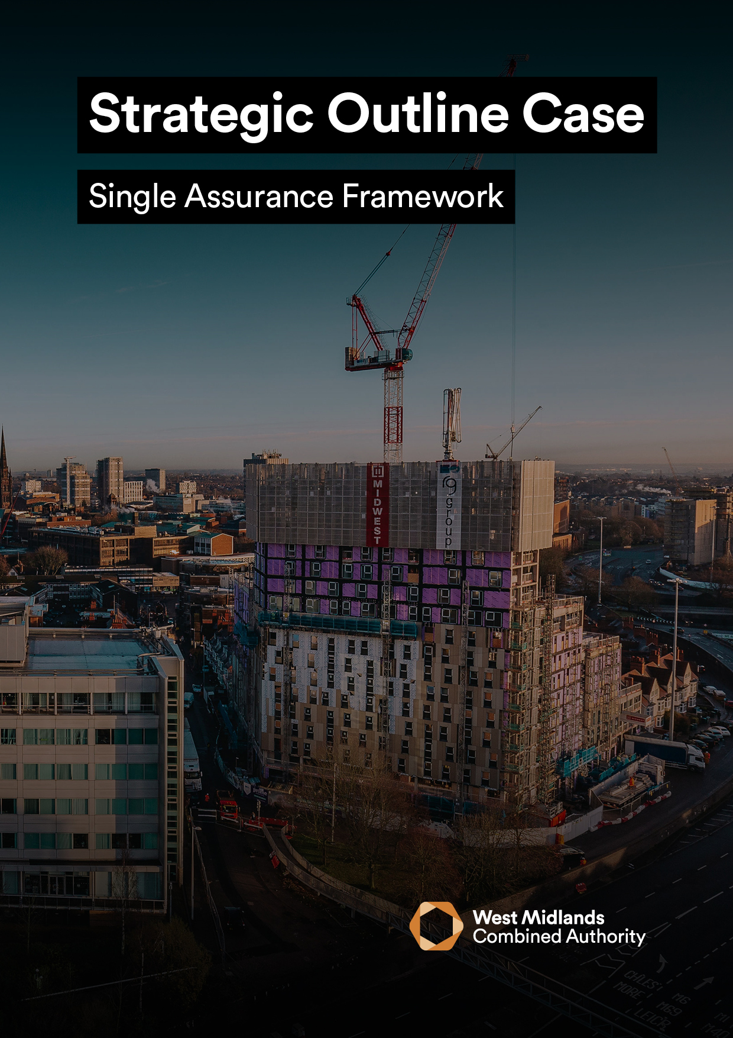
s
<INSERT PROJECT NAME>

STRATEGIC OUTLINE CASE VERSION 4.0
The Strategic Outline Case (SOC) is the scoping stage, its purpose is to:
- Confirm the strategic context of the proposal and make a robust Case for Change.
- Provide stakeholders with an early indication of the Preferred Way Forward (PWF), having undertaken a SWOT analysis of a wide range of available options, together with indicative costs and benefits.
It is a requirement that all SOC’s submitted to the West Midlands Combined Authority (WMCA) for public funds must:
- Outline the initial Case for Change. This must be completed in full but may be revised at later stages of the business case development.
- Complete a long-list of alternative options, with a recommended short-list for further examination at the OBC stage.
- Address the fundamentals of any potential procurement and deal within the Commercial Case.
- Discuss the likely affordability of the proposal within the Financial Case.
- Outline how the project will be set up and managed within the Management Case.

GUIDANCE
- To support better spending, investment decisions and better procurement, this Strategic Outline Case should be written using supplementary WMCA guidance, which can be found here.
- In addition, it is a requirement that all proposals for public funds submitted to WMCA are guided and based around the HM Treasury Green Book and supporting information, which can be found here.
- The input of key stakeholders must be detailed within Table 2, otherwise the business case will be rejected until this information is provided.
- Mandatory appendices as listed in Section 6.0 of this business case must be submitted as supplementary documents.
Table 1
PROJECT DETAIL
Project Name:
WMCA Directorate:
Delivery Team (if WMCA internal):
Organisation (if WMCA external):
WMCA Project Code:
GOVERNANCE
If external to WMCA, when was this project approved by your internal governance?
VERSION CONTROL
Version: |  |  | Date:
SOC Prepared by: |  |  | Job Title:

Table 2
STAKEHOLDER INVOLVEMENT
Please provide the names and level of input of the stakeholders listed below. Note that some are mandatory, and others are optional / dependent on the source of funding / nature of the project. This is made clear on the left of the table below and further explained in the supplementary guidance.
 | Role | Name | Input | Date
Mandatory | Senior Responsible Owner (SRO): |  | Choose an item.
 | WMCA Executive Director: |  | Choose an item.
 | Governance Services: |  | Acknowledged
 | Finance Lead: |  | Choose an item.
 | Legal Representative: |  | Choose an item.
 | Procurement Lead: |  | Choose an item.
 | Monitoring and Evaluation: |  | Choose an item.
Optional | Programme SRO:  (if applicable) |  | Choose an item.
 | Digital and Data Engagement and Delivery:  (if WMCA internal) |  | Choose an item.
 | WMCA Finance:  e.g., Major Programme Returns (if CRSTS/ Investment Programme funded): |  | Choose an item.
 | Human Resources: |  | Choose an item.
 | Transport Planning Assurance:  (if CRSTS funded) |  | Choose an item.
 | Cycling Team: |  | Choose an item.
 | Network Mitigations Forum: |  | Choose an item.
 | Inclusive Growth Team: |  | Choose an item.

EXECUTIVE SUMMARY

PLEASE PROVIDE A ONE-PAGE STAND-ALONE SUMMARY OF THE PROPOSED PROJECT WHICH INCLUDES (MAX 500 WORDS):

• A BRIEF PROJECT DESCRIPTION AND WHY IT IS necessary

• TARGET OBJECTIVES

• ASSOCIATED OUTPUTs

FINANCE SUMMARY
Table 3
Finance Summary | SOC (£)
Total Project Cost:
WMCA Funding Requested (within this business case):
WMCA Funding Source:
Funds Secured:
Funds Not Secured:

1 - STRATEGIC CASE
PROVIDING STRATEGIC FIT SUPPORTED BY A COMPELLING CASE FOR CHANGE

1.1 STRATEGY AND POLICY ALIGNMENT
Explain how the project supports the existing policies and strategies of the organisation, and the way other programmes and projects within the strategic portfolio are linked. In addition, comment on how Local, Regional, National Policy and other organisations’ strategies are supported. Attach relevant documents, if applicable.

1.2 ORGANISATIONAL OVERVIEW
Provide a brief overview of the organisation(s) making the Case for Intervention and Change.

1.3 EXISITING ARRANGEMENTS AND BUSINESS NEEDS
Provide a complete summary of the organisation’s current service model referring to its Business as Usual (BAU) offer, this may also include elements of services provided within the organisation’s external environment.
Also, state the deficiencies associated with the current provision and the implications if the project does not proceed.

1.4 PROJECT SPENDING OBJECTIVES AND ALIGNMENT TO WMCA AIMS
Specify the projects spending objectives and how they will be measured within the table below. They should focus on strategic rationale for intervention and the outcomes and benefits which support the aligned policies and strategies.
Objectives should be; bound by strategic context for project; focus on needs, not the solution; developed to facilitate realistic options for appraisal and SMART (Specific, Measurable, Achievable, Realistic and Time-Dependent). They will address at least one of the generic drivers for spend - improved effectiveness, efficiency, economy, compliance, replacement. Include objective(s) to reach the next business case stage e.g., OBC and entire project. Note, all projects need to consider Inclusive Growth and its contribution to Net Zero.
Table 4
# | Objective | Baseline  (Quantitative) | Target | Specific actions and when, to achieve objective | How will the customer be impacted?  (i.e., Outcomes) | Alignment to WMCA Aims and Objectives
1. |  |  |  |  |  | Choose an item.
2. |  |  |  |  |  | Choose an item.
3. |  |  |  |  |  | Choose an item.
4. |  |  |  |  |  | Choose an item.
5. |  |  |  |  |  | Choose an item.
6. |  |  |  |  |  | Choose an item.

1.5 INCLUSIVE GROWTH AND EQUALITIES
Explain how this project will contribute to inclusive growth and equality within the West Midlands. If WMCA internal, the WMCA’s Inclusive Growth Framework can be found here. To add, state how health inequalities and equalities (protected characteristics as defined by the Equality Act) have been considered in the production of this business case. This can be done using the WMCA Health and Equity Impact Assessment (HEQIA) Tool found here for internal staff, or other tools available within Local Authorities. If you are external to WMCA but wish to use our HWQIA Tool, contact equalitiesteam@wmca.org.uk.

1.6 MAIN BENEFITS
Specify the main benefits associated with the achievements of the project’s spending objectives by type and beneficiary. Distinguish benefits from outcomes.
Table 5
# | Benefit | Benefit Classification | Benefit Type | Beneficiary(s)
1. |  | Choose an item. | Choose an item.
2. |  | Choose an item. | Choose an item.
3. |  | Choose an item. | Choose an item.
4. |  | Choose an item. | Choose an item.
5. |  | Choose an item. | Choose an item.

1.7 KEY RISKS
Specify the key risks associated with the achievement of the project’s objectives, along with the key activity aimed at either managing the cause or mitigating the effects of each risk.
This should be aligned with the project Risk Register appended to this SOC.
Table 6
ID | Risk | Impact  (1-5) | Probability  (1-5) | RAG  Rating | Risk  Owner | Mitigation

1.8 CONSTRAINTS
Specify any constraints that have been placed on the project.

1.9 DEPENDENCIES
Specify any dependencies outside the scope of the project upon which the success of the project is dependent.

2 - ECONOMIC CASE
MAXIMISE PUBLIC VALUE TO SOCIETY THROUGH THE SELECTION OF THE OPTIMAL COMBINATION OF SCOPE, COSTS AND OUTCOMES

2.1 CRITICAL SUCCESS FACTORS
List the Critical Success Factors i.e., what must this project achieve to be successful?
These are not outcomes or objectives; they are the attributes essential for successful delivery of the project.
Table 7
# | Critical Success Factor (CSF) | Alignment to Project Objectives
1.
2.
3.
4.
5.

2.2 LONG-LIST OF OPTIONS
Determine the long-list options and undertake SWOT (strengths, weaknesses, opportunities, threats) analysis to complete the table below. All supporting evidence informing the long-list together should be made available if requested for reference and/or Assurance and Appraisal purposes.
Information provided for the short-list options should also feature below.
Table 8
# | Option Description | Advantages  (Benefits) | Disadvantages  (Disbenefits) | Meets the Objectives and CSFs of this project?  (Y/N)
1.
2.
3.
4.
5.
6.
7.
9.
10.
11.
12.

2.3 SHORT-LISTED OPTIONS AND APPRAISAL
Describe the short-list to be examined in further detail at the next business case stage. This should include a minimum of 3 to 5 options as listed below. Indicative Present Value of Benefits (PVB), Present Value of Costs (PVC) and Net Present Social Value (NPSV) [NPSV = PVB – PVC; BCR = PVB/PVC] should be provided for the proposed SOC short-list. Where this is not possible for all options, please provide values for the Preferred Way Forward at minimum and provide rationale as to why calculations could not be completed.
Note, this information should align to the long-listed options outlined in Section 2.4 of this SOC.
Table 9
Option Label | Business as  Usual  (baseline) | Do-minimum  Option | Preferred  Way Forward  (If not Do-  Minimum) | More ambitious Preferred Way Forward | Less ambitious Preferred Way Forward
Description of Option

Indicative net present social value (NPSV)

Indicative relevant present value public sector cost (PVC)

Residual risk and optimism bias allowances
Indicative benefit cost ratio (BCR)

Provide quantified benefits for the following items. Note that inclusion here is independent of the social benefits and BCR calculation, and not all items should be included in a HM Treasury Green Book appraisal.
Table 10
Item | Quantified benefit | Social benefit included in BCR
GVA | £m increase in WM GVA over x years | N/A
Jobs created | Number created in WM over x years | N/A
Houses built | Number built in WM over x years | N/A
Carbon emissions | X tonnes saved over x years | Valued using latest HMT values

2.4 PREFERRED WAY FORWARD
Outline the recommended Preferred Way Forward as identified in the options appraisal above (scope, solution, service delivery, implementation and funding) for the project.

3 - COMMERCIAL CASE
COMMERCIALLY VIABLE AND ATTRACTIVE TO THE SUPPLY SIDE
Athough the Commercial Case is not expected to be matured at SOC stage, the nature of work should be identified to inform the next stage i.e., sound out the market and inform the procurement process in the next stage (OBC). With this in mind, please complete the questions listed below to support the Commercial Case.

3.1 OVERVIEW OF COMMERCIAL CASE IN SUPPORT OF PREFERRED WAY FORWARD
State the ability of the marketplace to provide the required goods or services and the attractiveness of this proposal to potential service providers.

3.2 OVERVIEW OF THE COMMERCIAL STRATEGY
References the organisations Commercial Strategy and how public value will be achieved through economies of scale.

4 - FINANCIAL CASE
AFFORDABLE AND FUNDABLE OVER TIME
Unrounded figures should be used throughout the Financial Case. State how project costs have been ratified and by whom.

4.1 CAPITAL FUNDING AND REVENUE FUNDING STATEMENT
A summary of the overall affordability of the project and the funding that has been secured to date must be provided.
All secured funding identified below should be verified by a written confirmation attached to this SOC with details of any conditions etc. Note that any funding requested via this SOC is “unsecured” until approval of the Full business case (FBC).
Table 11
 | Status  (Secured / Not Secured) | £M
Revenue
Capital
Total
Development Funding within the above (funding required to reach the next stage)
Funder | Amount | % of Total | Status  (Secured / Not Secured) | Details of Funding Status / Timing / Conditions etc.
Total | £ | 100%

Table 12

4.2 OVERVIEW OF FUNDING AND AFFORDABILITY SUMMARY
A written summary of the overall affordability of the project and the funding that has been secured to date must be provided. Where there is a shortfall in available funding, provide details of how this will be addressed, and the level of contingency included.

Complete the table below to provide an overview of the WMCA funding:
Table 13
Funding Type
Grant / Cashflow (repayable) / Underwrite
Funding Commencement Date | DD/MM/YY
Funding Completion Date | DD/MM/YY
Basis of Reimbursement
Quarterly in arrears of expenditure incurred (WMCA Standard)
Any Conditions Precedent?

e.g., securing DfT funding. Include any spend deadline/s, eligible spend outputs and high priority items likely to be included in any Conditional Grant offers or development agreements in principle (Heads of Terms)
Order in which WMCA Funding is to be drawn
1st/2nd/3rd

Work streams for which WMCA Funding is available to be drawn against

e.g., all / workstream 1, 3 and 4 etc.

4.3 COST BREAKDOWN
Project Spend to date
Expense Item | Cost/Budget (£) | Capital/Revenue
(Example – Personnel)
(Example - Consultancy Fees)
(Example - Design)
(Example - Construction)
(Example - Marketing)
Development costs for next stage business case [OBC]
Include further line items as required
Budget Forecast
Expense Item | Cost/Budget (£) | Capital/Revenue
(Example – Personnel)
(Example - Consultancy Fees)
(Example - Design)
(Example - Construction)
(Example - Marketing)
M&E budget
Include further line items as required
Spend to Date | £ | Revenue
 | £ | Capital
Forecast | £ | Revenue
 | £ | Capital
Complete the table below detailing the breakdown of project expenditure to date and forecasted costs. Include the costs to develop to the next Business Case stage.
Table 14

5 - MANAGEMENT CASE
CAN BE DELIVERED SUCCESSFULLY BY THE ORGANISATION AND ITS PARTNERS

5.1 MANAGEMENT AND GOVERNANCE
Provide an overview of the necessary management and governance arrangements both in the delivery phase and in operation i.e., include detail on:
- Governance and decision-making arrangements
- Change management arrangements (inc. reference to WMCA Change Process)
- Outline benefits realisation arrangements and plans, including initial benefits register
- Outline contract management arrangements
- Post evaluation arrangements

5.2 PROJECT SCHEDULE FOR DELIVERY
List the key project milestones and ensure this information is fully aligned to the Project Schedule, which must be appended to this SOC. Include dates for future business case submissions (i.e., OBC) and a longstop date by which all monies for development of this SOC needs to be drawn by.
Table 15
# | Milestone | Start Date | End Date
1.
2.
3.
4.
5.
6.
7.
9.
10.

5.3 PROJECT ORGANOGRAM
Insert a Project Organogram which includes distinguishes between full-time, part-time and fixed term staff. A Senior Responsible Owner (SRO) should be appointed and identified in the organogram.

5.4 PROJECT DELIVERY ROLES AND RESPONSIBILITES
Classify the roles and tasks to determine who is Responsible (R), Accountable (A), Consulted (C) and Informed (I).
Table 16
 | <Insert Role> | <Insert Role> | <Insert Role> | <Insert Role> | <Insert Role>
<Insert Task> | Choose an item. | Choose an item. | Choose an item. | Choose an item. | Choose an item.
<Insert Task> | Choose an item. | Choose an item. | Choose an item. | Choose an item. | Choose an item.
<Insert Task> | Choose an item. | Choose an item. | Choose an item. | Choose an item. | Choose an item.
<Insert Task> | Choose an item. | Choose an item. | Choose an item. | Choose an item. | Choose an item.
<Insert Task> | Choose an item. | Choose an item. | Choose an item. | Choose an item. | Choose an item.

5.5 LESSONS LEARNT
Detail how Lessons Learnt have been considered during development of the proposal and factored into the production of this business case.

5.6 MONITORING AND EVALUATION
Set out a summary of the initial Monitoring Evaluation arrangements for the project and milestones to progress towards completion of the next business case stage i.e., OBC.
Further steer is set out within the Strategic Business Case (SOC) guidance document and Performance Team Intranet Page.
For additional support with completing the M&E template pleases contact the M&E team: CorporateMonitoringEvaluation@wmca.org.uk

6 - MANDATORY APPENDICES REQUIRED FOR THIS SOC
Please provide each of the mandatory appendices listed below as a separate Word/Excel document – do not embed in the Business Case or provide PDFs.
If any appendices are missing, your business case may be rejected until missing appendices are provided.
Table 17
APPENDIX |  | PROVIDED (Y/N)
A | Risk Register and Issue Log
B | Stakeholder and Communications Strategy
C | Written Confirmation(s) of Confirmed Funding
D | Project Schedule
E | If WMCA funding required is between £1-5 million, WMCA Individual Executive Director Decision Template
F | If WMCA funding required is over £5 million, All Board / Committee Report Template
G | If Investment Programme, Project Delivery Plan on a Page (POAP)
H | If CRSTS, Additional Appendix

