Net Zero & Environment: Community Participation Principles

Purpose of the Document
This document is intended to set out best practice when organising, engaging or speaking with communities and neighbourhoods around Net Zero, sustainability and low-carbon technologies, including key considerations for each stage of the engagement process.
How to Use This Document
Contained are key considerations to navigate a community engagement programme. From the initial stages of planning, through to the delivery and analysis of engagement efforts, this document provides a core set of considerations for each stage. This is not intended to be prescriptive. Rather than offering rigid instructions, it outlines underlying principles that drive inclusive and effective community engagement. As such, it should serve as a guide, encouraging adaptability and creativity in tailoring engagement approaches to the unique contexts and needs of each community. A version of this document should also be shared as guidance with Local Authority partners actively delivering Net Zero & Environment projects that involve community participation (e.g Net Zero Neighbourhoods, delivery of Heat Networks, community owned low carbon generation, etc.)
Understanding the Principles
At its core, this document emphasizes principles that underpin inclusive community engagement. It encourages openness, transparency, and collaboration, recognizing the value of diverse perspectives and lived experiences. By embodying these principles, we create space for meaningful dialogue, co-creation, and empowerment within our communities. By emphasizing principles such as those outlined in Arnstein's ladder of participation, we aim to promote genuine collaboration, where communities are not spectators, but active partners in the decision-making processes around their place. It underscores the critical need to move beyond tokenistic engagement efforts, recognizing that poorly designed or implemented engagement can have detrimental effects, perpetuating disempowerment, and distrust within communities.
Inclusive Growth
Inclusive Growth is defined as:
‘A more deliberate and socially purposeful model of economic growth, measured not only by how fast or aggressive it is; but also, by how well it is created and shared across the whole population and place, and by the social and environmental outcomes it realises for our people.’
In essence, this gives our work the overarching goal of ensuring that everything we do contributes to creating opportunities for all our citizens to live fulfilling lives and thrive, while also respecting the boundaries of our living planet. Inclusive growth is often understood in doughnut form, with the WMCA’s inclusive growth doughnut having eight themes: Climate resilience, affordable and safe places, education and learning, connected communities, health and wellbeing, power and participation, inclusive economy and equality.
It was with the Inclusive Growth Framework that these guidelines were created. The Framework seeks to translate inclusive growth from an intellectual concept into a reality, and it is this approach that was the basis for this work.
Planning  (before) | Delivery  (during) | Analysis  (after)
Aim: To understand the people we will engage with, so that the engagement can be tailored to the people. | Aim: Put co-creation at the heart of engagement to collaborate with communities and give them ownership. | Aim: Evaluate the success of the co-creation and analyse the responses.
Deliverables:  - Setting out objectives and targets (be very clear on why the engagement is happening, what the benefits of engaging are and what impact the decisions may have on the place)  - Gather relevant pre-engagement data to build a baseline picture of the place (can use the Inclusive Growth doughnut to help frame this.)  - Gather local insights and sentiments- engage with Local Authority (if LA not leading) and connect with community groups to understand existing activities, key local issues, concerns any potential hooks for the specific community.  - Identifying the demographics of the population/s we are engaging and how best to reach them.  - Mapping out key stakeholders within the community and keeping informed from the planning stage to ensure they are aware of how they can influence delivery and impact.  - Agreeing a budget, ensuring there’s sufficient funds and resource to deliver inclusive and accessible engagement. This should be reflected in procurement specifications and contracting where relevant.  - Review previous consultations/ engagements in the area that have sought similar information, to ensure we’re not duplicating effort or over-consulting.  - Defining appropriate approach to engagement and associated timeline. | Deliverables:  - Enable local people to design or influence a policy, service, or infrastructure project.  - Be carried out as early as possible in the development of a policy, service, or project.  - Ensure planned activities are inclusive and accessible.  - Respond to feedback by making changes to proposed interventions.  - Work with WMCA to identify ongoing activities that may support engagement work. For example, Race Equalities Task Force, TfWM online community, Greener Together Citizens Panel.  - Work WMCA Engagement team.  - WMCA Engagement team can support with outreach, engagement, and consultation activity.  - Communicate regularly with WMCA on progress.  - Continually review and update engagement methods and approach to increase response rate. | Deliverables:  - Produce report summarising responses and reviewing engagement tactics.  - Lessons learned will be shared with the WMCA.  - Must have a dedicated communications and engagement plan to keep in touch with our stakeholders if there will be a significant gap between the engagement ending and a project or  - intervention being implemented.

Glossary:
Net Zero- the total greenhouse gas (GHG) emissions of an organisation (or city, or state) are equal to or less than the emissions it removes from the environment​. The WMCA has committed the region to achieve net zero by 2041.
Sustainability- the practice of using natural resources responsibly today, so they are available for future generations tomorrow (National Geographic).
Heat networks- Heat networks (also known as district heating) supply heat from a central source to consumers, via a network of underground pipes carrying hot water. Heat networks can cover a large area or even an entire city, or be fairly local supplying a small cluster of buildings (DESNZ).
Neighbourhood- an ultra-local community of place.
Community participation- achieved through co-production, where the community work together and directly participate in projects: from design to delivery, to the sharing of strategic decision-making about policies as well as decisions about the best way to deliver services (thinklocalactpersonal).
Community owned- where local people have control over the buildings and spaces that have significance to them, so that these spaces are used in ways that meet the priorities and needs of the local community (MyCommunity).
Arnstein’s Ladder - Arnstein's ladder, proposed by Sherry Arnstein in 1969, is a conceptual framework that describes levels of citizen participation in decision-making processes. It consists of eight rungs, ranging from non-participation to citizen control, illustrating the varying degrees of power and influence that individuals or groups may have in shaping policies or projects. This ladder serves as a tool for analysing the effectiveness and inclusivity of participatory practices in governance and planning.

Zero Carbon Rugeley (pure co-design) | Community BEES (co-design leading to delivery of interventions) | Link Road (co-design leading to delivery of interventions) | Retrofit Balsall Heath (co-design leading to delivery of interventions)
Picture & project partners  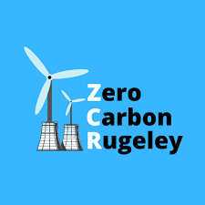  Lead partner: EQUANS  Community engagement partner: Keele University  Objective  Co-designing a Net Zero plan for the Rugeley area, including democratisation of decision making through a hyper-local governance system.  Approach to engagement  Over the three-year duration of the project the activity was iterative, with learning from the community and reflection on the process leading to refinement in the approach. The overarching structure of the approach comprised three (often overlapping) phases:  1) Exploratory: In this phase activities were designed to develop a broad understanding of: the community; the local context and perceptions of the local area and its challenges both generally and in relation to different energy vectors and services; opportunities and areas of pride or concern; and the community’s willingness to engage in the community-centric design process. This phase also provided understanding of the community’s perceptions of the project, its aims and the concept of a smart local energy system.  2) Specific: This phase focused of activities exploring specific elements of the SLES with the local community, in terms of acceptance of technologies and different business models, the willingness to adopt different technologies, levels of understanding of the proposed solutions, and envisioned implications of embedding these technologies within the community. Activities in this phase ranged from workshops for in-depth exploration of issues with engaged community members, to short, ‘drop-in’ engagements through ‘pop-up’ events. Project consortium members were encouraged to consider how community input might be useful to refining the specific design components.  3) Legacy: This phase reflects activities and resourcing of the community to support a legacy of activity for the community to be able to continue work supporting place-based decarbonisation beyond the funded scope of the project.  How NZN guidelines were applied  This is the gold-standard. Some pieces of the NZN guidance do not carry over, as this work was purely theoretical, with no interventions being delivered.  Outcomes, findings and lessons learnt  - Ensure dedicated, significant resource for a community-centric design team throughout the duration of the project from a partner organisation trusted by the community.  - Ensure the principle of community-centric design is embedded in project design and governance from the start.  - Develop trusted relationships and communication channels with key community stakeholders who can act on community insights.  - Provide opportunities for the technical teams to engage directly with the community.  - Identify community gatekeepers and maintain relationships throughout, identifying win-wins where possible.  - Prioritise your audience and try to include small, local businesses.  - Develop a network of community ambassadors – and support them to achieve their own community goals.  - Use a range of approaches for engagement – online, in-person, deep and shallow and of different time intensity.  - Use social media for two-way interaction.  - Consider and build project legacy from the start. | Picture & project partners  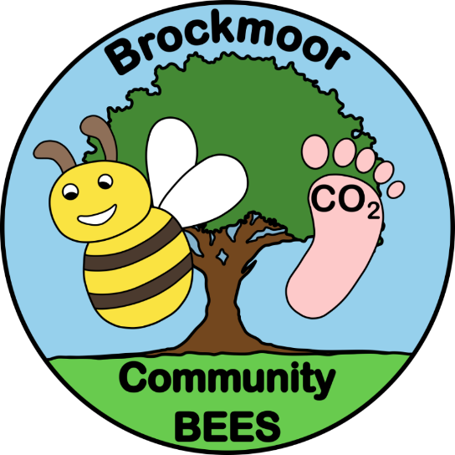  Lead partner: Dudley MBC  Community engagement partner: Keele University  Objective  To test the hypothesis that a retrofit programme built on a foundation of community engagement, supported with active travel and green infrastructure interventions achieves higher sign-up rates, and lower dropout rates.  Approach to engagement  The engagement approach in Brockmoor has been adapted from that deployed for ZCR.  Keele University have developed a community engagement plan and are the responsible party for delivery, acting to coordinate activities between all project partners and the Brockmoor community.  Early stages of the engagement have focused on understanding the Neighbourhoods attitudes and understanding of Net Zero, as well as identifying key anchor issues in the community. This has helped frame the engagement materials, focusing on issues that resonate with residents.  How NZN guidelines were applied  Many good examples including:  - Thorough analysis of engagement activities undertaken in the neighbourhood to date conducted while developing the engagement plan.  - Identification and engagement with key community pillars, Brockmoor Primary School and Friends of Brockmoor Park.  - Accessible engagement events, being present during evenings and weekends, at easily accessible venues.  - Project governance processes established to ensure oversight of engagement work.  - Learnings from engagement events have been actioned to improve accessibility and increase uptake.  Outcomes, findings and lessons learnt  - Community engagement at this level costs more than initially anticipated, and has required available, and flexible resourcing. For example, DMBC officers have been door knocking on weekends to ensure residents are more likely to be in.  - Engagement activities have been planned by the Keele team, but staffed with representatives across the project partners. This has helped build specific skill sets and has helped with capacity within the LA. | Picture & project partners  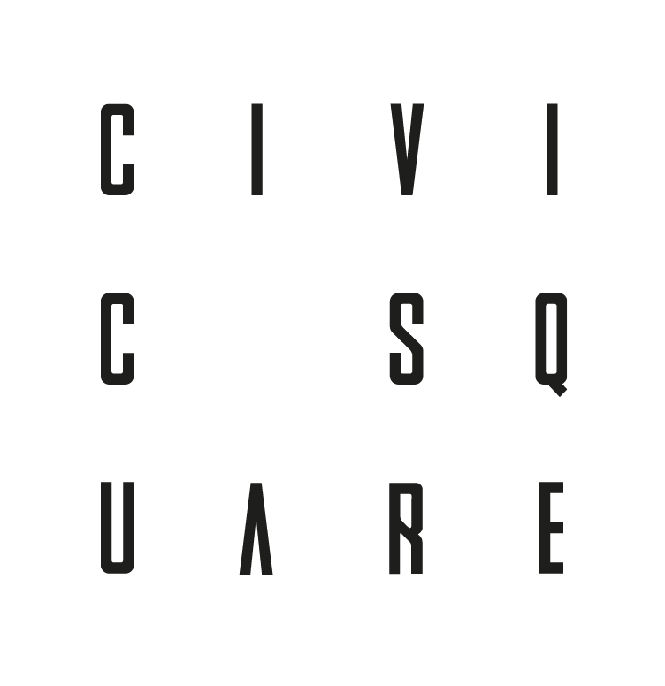  Lead partner: Civic Square  Community engagement partner: Civic Square/ Ladywood residents  Objective  Visioning, building and investing in social and civic infrastructure for neighbourhoods of the future using Kate Raworths doughnut principles as a compass for action. The team is based in Ladywood, Birmingham with a physical site at Port Loop and a neighbourhood demonstrator at Link Road.  Approach to engagement  The Civic Square team recognised that true co-creation is a long term journey. They prioritised building relationships and trust with their Ladywood and Link Road neighbours, by providing a consistent, accessible and long-standing presence in the area. Through co-creation initiatives such as their ‘virtual living room’, the Regenerative Neighbourhoods Festival, the Link Road Supper Club, funded Peer-To-Peer learning journeys and the Neighbourhood Trade School they have developed a huge amount of buy-in to neighbourhood regeneration, and upskilled the community to lead delivery on a wide range of different projects.  .  This ties into the underlying ethos of Civic Square’s engagement approach – which rather than parachuting in, attempting to lead a project with the community, empowers and provides the space and infrastructure required for residents to design, lead, and deliver projects that work best for the neighbourhood.  In Civic Square’s own words, their approach to engagement can be summarised through the following ‘crafts’:  - Grounding – A humble, supportive, critical space to return to, to (re)discover, (re)design and (re)establish value, and ground back in to the mission.  - Starting Where We Are –  Getting our own home in order,  centring the neighbourhood, the existing expertise and ideas of its histories, wisdom and assets.  - Research, Reframe –  A space to keep interrogating and shaping the scope of the work, and continually reframe the challenge from deficit to opportunity.  - Making Visible, Reimagining –  Collectively making visible the  For more information on the approach to community engagement undertaken by Civic Square, see their Notion pages, which holds all of their work to date.  This is published under the Collective Commons and isfreely available.  How NZN guidelines were applied  - Framing engagement around a central theme to ensure consistent messaging.  - Develop an understanding of the place, both quantitatively through data, and qualitatively by listening to peoples lived experiences.  - Ensuring events are accessible to all.  - Deliver on the things that matter most to residents, and empower them to make informed decisions by sharing knowledge about potential outcomes, both positive and negative.  - Continually reviewing engagement approaches to find what works best for the neighbourhood, and adapting as appropriate.  Outcomes, findings and lessons learnt  - Access to events, physical access, as well as time and cost acted as a barrier for some residents .As such, lots of activities were held on Link Road itself, with a travel bursary available for events held further away.  - As this programme is intended to be a long-term journey, the team provided micro-grants as part of the ‘Dream Fund’ equivalent to ~£1000 per household for residents to access. Interestingly some residents pooled these grants to deliver higher-impact, shared resources. As such, these small grants delivered both small wins to keep momentum and provided space for hyper-local governance to develop.  - The team also notes that this approach to engagement is resource intensive. However, developing a great level of trust, supporting a space for democratic ownership of projects, and appropriate sharing of knowledge, has supported the development of a huge amount of buy-in to retrofit and decarbonisation in the street. | 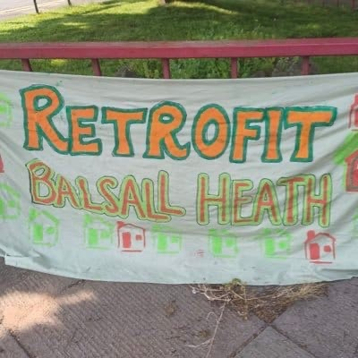  Picture & project partners  Lead partner: John Christophers – Zero Carbon House  Community engagement partner: Balsall Heath Residents  Objective  To deliver neighbourhood regeneration measures across Balsall Heath, impacting homes, transport, and community spaces, that critically, leaves nobody behind.  Approach to engagement  A Strong focus on the ‘hard graft’ around engagement and generating buy-in, by being active and visible in the neighbourhood. This involves lots of door-knocking, gaining an understanding of the best ways to reach different people and different groups. Crucially, this is delivered by empowered Balsall Heath residents. Key local stakeholders have been brought into the vision for Retrofit Balsall Heath, providing strong outreach into their communities.  Rather than setting up Retrofit Balsall Heath to operate in isolation, the team have worked closely with existing organisations to coordinate messaging and supported upskilling to help advise on energy advice and retrofit pathways.  How NZN guidelines were applied  - Gather a deep understanding of the existing community infrastructure in Balsall Heath.  - Investigate prior engagement activities/ communications around retrofit that have occurred in the neighbourhood.  - Working in the open – Retrofit Balsall Heath have been very open in sharing their approach to engagement.  Outcomes, findings and lessons learnt  - ‘Open houses’ during and after measures are installed to show residents what a retrofit journey looks like.  - Successfully onboarded ~1500 homes in the neighbourhood, with upwards of 95% coverage in some streets.  - Supported residents in accessing retrofit funding for ~700 homes.  - Negotiated better terms for funding, that are more aligned with the needs of residents. Stemming from the great understanding of local needs, developed through engagement.  - Generated sufficient buy-in for engagement to continue organically (Peer-to-peer engagement).  - Successful delivery has provided lots of positive stories. Strong communications around these stories has created greater visibility of the programme.  - Proactively raised offers to the local council to expedite engagement activities to ensure funding is delivered effectively in the neighbourhood.

