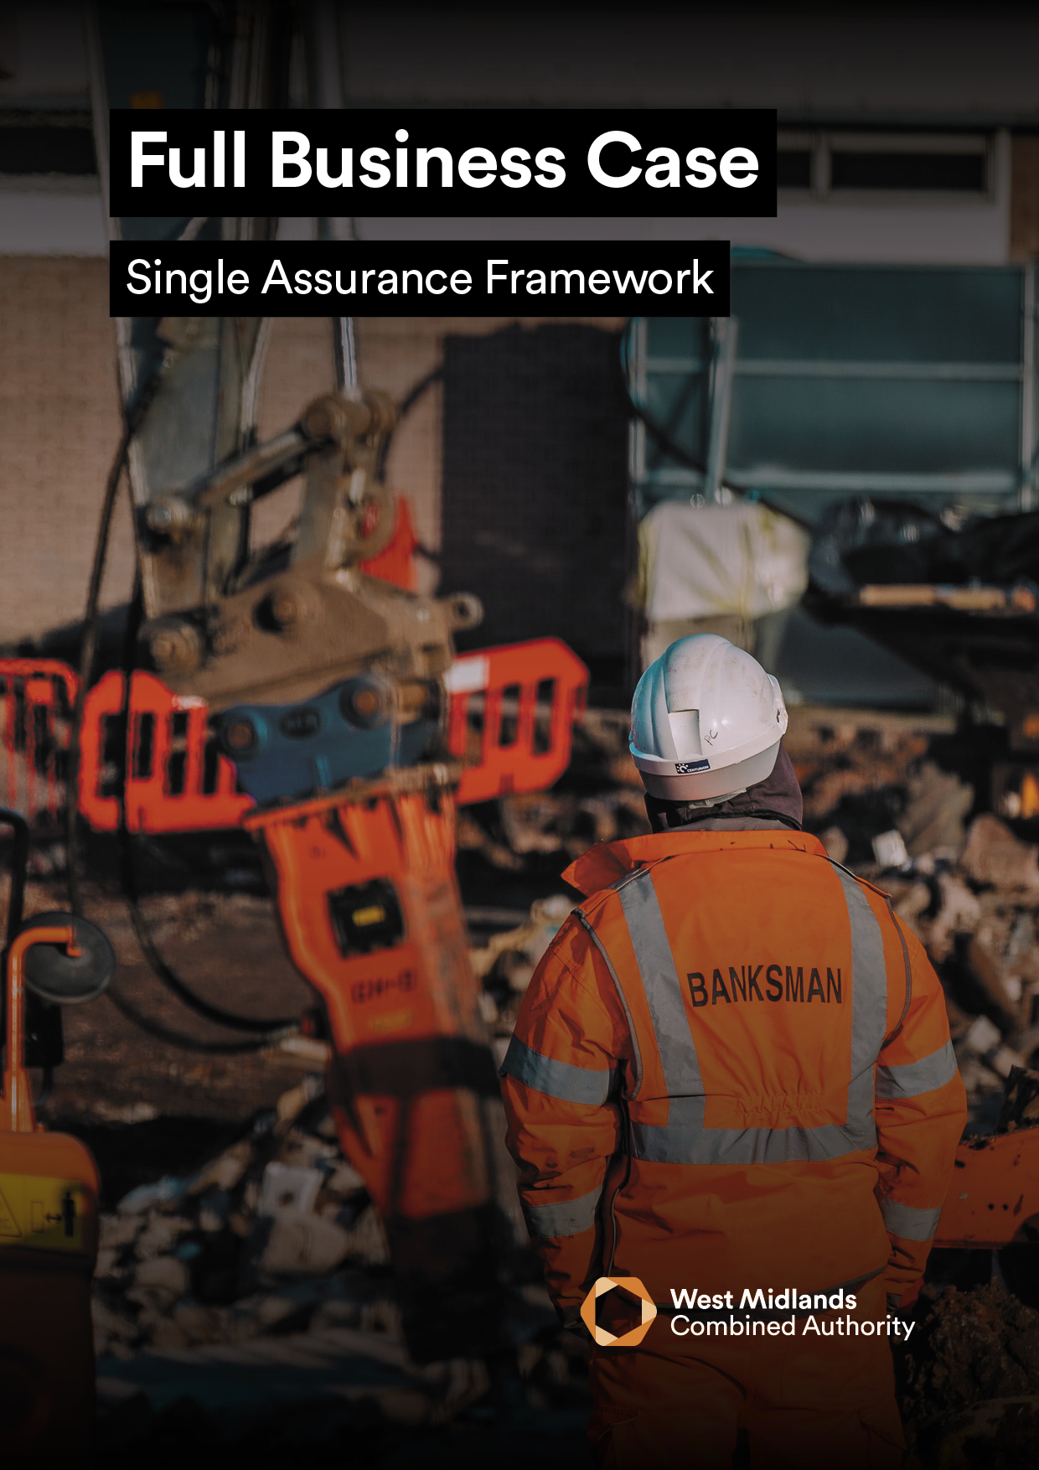
<INSERT PROJECT NAME>

<INSERT PROJECT NAME>

FULL BUSINESS CASE VERSION 4.0
The purpose of the Full Business Case (FBC) is to select the most economically advantageous tender (MEAT) and to put in place the management arrangements for the successful delivery of the project’s outputs and activities.
In addition, the FBC records:
- contractual arrangements,
- confirms affordability, and
- puts in place the agreed management arrangements for the delivery, monitoring and post-evaluation of the project.
It is a requirement that all FBC’s submitted to the West Midlands Combined Authority (WMCA) for public funds must:
- Confirm the Preferred Option as identified in the Outline Business Case (OBC) and provide the detailed plans associated.
- Set out the agreed deal, affordability, supporting procurement strategy and management arrangements for successful roll out of the project. Key contractual clauses and payment mechanisms should be demonstrated within the Commercial Case.
- Complete the Economic Case according to the Green Book.
- Contain a detailed analysis of affordability and funding gaps within the Financial Case.
- Outline the project management plan and methodology within the Management Case.

GUIDANCE
- To support better spending, investment decisions and better procurement, this Full Business Case should be written using supplementary WMCA guidance, which can be found here.
- In addition, it is a requirement that all proposals for public funds submitted to WMCA are guided and based around the HM Treasury Green Book and supporting information, which can be found here.
- The input of key stakeholders must be detailed within Table 2, otherwise the business case will be rejected until this information is provided.
- Mandatory appendices as listed in Section 6.0 of this business case must be submitted as supplementary documents.
Table 1
PROJECT DETAIL
Project Name:
WMCA Directorate:
Delivery Team (if WMCA internal):
Organisation (if WMCA external):
WMCA Project Code:
GOVERNANCE
If external to WMCA, when was this project approved by your internal governance?
VERSION CONTROL
Version: |  |  | Date:
FBC Prepared by: |  |  | Job Title:

Table 2
STAKEHOLDER INVOLVEMENT
Please provide the names and level of input of the stakeholders listed below. Note that some are mandatory, and others are optional / dependent on the source of funding / nature of the project, this is made clear on the left of the table below and further explained in the supplementary guidance.
 | Role | Name | Input | Date
Mandatory | Senior Responsible Owner (SRO): |  | Choose an item.
 | WMCA Executive Director: |  | Choose an item.
 | Governance Services: |  | Acknowledged
 | Finance Lead: |  | Choose an item.
 | Legal Representative: |  | Choose an item.
 | Procurement Lead: |  | Choose an item.
 | Monitoring and Evaluation: |  | Choose an item.
Optional | Programme SRO:  (if applicable) |  | Choose an item.
 | Digital and Data Engagement and Delivery:  (if WMCA internal) |  | Choose an item.
 | WMCA Finance:  e.g., Major Programme Returns(if CRSTS/ Investment Programme funded) : |  | Choose an item.
 | Human Resources: |  | Choose an item.
 | Transport Planning Assurance:  (if CRSTS funded) |  | Choose an item.
 | Cycling Team: |  | Choose an item.
 | Network Mitigations Forum: |  | Choose an item.
 | Inclusive Growth Team: |  | Choose an item.

EXECUTIVE SUMMARY

PLEASE PROVIDE A ONE-PAGE STAND-ALONE SUMMARY OF THE PROPOSED PROJECT WHICH INCLUDES (MAX 500 WORDS):

• A BRIEF PROJECT DESCRIPTION AND WHY IT IS necessary

• TARGET OBJECTIVES

• ASSOCIATED OUTPUTs

FINANCE SUMMARY

Table 3
Finance Summary | FBC (£)
Total Project Cost:
WMCA Funding Requested (within this business case):
WMCA Funding Stream:
Funds Secured:
Funds Not Secured:

1 - STRATEGIC CASE

PROVIDING STRATEGIC FIT SUPPORTED BY A COMPELLING CASE FOR CHANGE

1.1 PROJECT SPENDING OBJECTIVES AND ALIGNMENT TO WMCA AIMS
Specify the spending objectives for the project. These should focus on the target outcomes for the intervention and be SMART (Specific, Measurable, Achievable, Realistic and Time-Dependent). They will address at least one of the generic drivers for spend - improved effectiveness, efficiency, economy, compliance, replacement.
Note, all projects need to consider Inclusive Growth and its contribution to Net Zero.
Table 4
# | Objective | Baseline  (Quantitative) | Target | Specific actions to achieve objective | How will the customer be impacted?  (i.e. Outcomes) | Alignment to WMCA Aims and Objectives
1. |  |  |  |  |  | Choose an item.
2. |  |  |  |  |  | Choose an item.
3. |  |  |  |  |  | Choose an item.
4. |  |  |  |  |  | Choose an item.
5. |  |  |  |  |  | Choose an item.
6. |  |  |  |  |  | Choose an item.

1.2 INCLUSIVE GROWTH AND EQUALITIES
Explain how this project will contribute to inclusive growth and equality within the West Midlands. If WMCA internal, the WMCA’s Inclusive Growth Framework can be found here. To add, state how health inequalities and equalities (protected characteristics as defined by the Equality Act) have been considered in the production of this business case, this can be done using the WMCA Health and Equity Impact Assessment (HEQIA) Tool found here for internal staff, or other tools available within Local Authorities. If you are external to WMCA but wish to use our HWQIA Tool, contact equalitiesteam@wmca.org.uk.

1.3 KEY RISKS
Specify the key risks associated with the achievement of the project’s objectives, along with the key activity aimed at either managing the cause or mitigating the effects of each risk.
The information provided should be an extract from the Risk Register and Issue Log attached with this FBC.
Table 5
ID | Risk | Impact  (1-5) | Probability  (1-5) | RAG  Rating | Risk  Owner | Mitigation

1.4 CONSTRAINTS
Specify any constraints that have been placed on the project.

1.5 DEPENDENCIES
Specify any dependencies outside the scope of the project upon which the success of the project is dependent.

2 - ECONOMIC CASE

MAXIMISE PUBLIC VALUE TO SOCIETY THROUGH THE SELECTION OF THE OPTIMAL COMBINATION OF SCOPE, COSTS AND OUTCOMES

2.1 CRITICAL SUCCESS FACTORS
List the critical success factors i.e., what must this project achieve to be successful?
These are not outcomes or objectives; they are the attributes essential for successful delivery of the project.
Table 6
# | Critical Success Factor (CSF) | Alignment to Project Objectives
1.
2.
3.
4.
5.

2.2 SHORT-LISTED OPTIONS AND APPRAISAL
Prepare the economic appraisals for the short-list options in the table below and confirm that the options identified in the OBC are still valid and their rankings remain the same.
Table 7
Option Label | Business as  Usual  (baseline) | Do-minimum  Option | Preferred  Option  (If not Do-  Minimum) | Option 3  (More ambitious) | Option 4
Description of Option

NPSV for CBA or Net Present Unit Cost, NPUC for CEA
Relevant present value public sector cost
Appropriate BCR or NPUC
Significant Quantified but unmonetizable benefits
Significant unquantifiable benefits
Residual risk and optimism bias allowances
Switching values of key variables
Life span of the option

2.3 BENEFITS APPRAISAL
Validate the main benefits associated with the achievements of the project’s spending objectives by beneficiary. Distinguish benefits from outcomes.
This should be aligned with the Outline Benefits Realisation Plan / MEP appended to this FBC.
Table 8
# | Benefit | Benefit Classification | Beneficiary(s)
1. |  | Choose an item.
2. |  | Choose an item.
3. |  | Choose an item.
4. |  | Choose an item.
5. |  | Choose an item.

Provide quantified benefits for the following items. Note that inclusion here is independent of the social benefits and BCR calculation, and not all items should be included in a Green Book appraisal.
Table 9
Item | Quantified benefit | Social benefit included in BCR
GVA | £m increase in WM GVA over x years | N/A
Jobs created | Number created in WM over x years | N/A
Houses built | Number built in WM over x years | N/A
Carbon emissions | X tonnes saved over x years | Valued using latest HMT values

2.4 PREFERED OPTION SENSITIVITY ANALYSIS
Using the Preferred Option, undertake a sensitivity analysis as outlined below.
Table 10
Category | Assumptions and Estimates | %
Costs and Benefits (£) | Capital Costs
 | Lifecycle Costs
 | Costs of Core Services
 | Costs of Non-core Services
 | Benefits Valued in Monetary Terms
Non-monetisable Benefits | Quantifiable and Qualitative
Timing | Delays in Project

3 - COMMERCIAL CASE
COMMERCIALLY VIABLE AND ATTRACTIVE TO THE SUPPLY SIDE

3.1 PROCUREMENT ARRANGEMENTS
Provide an overview of the procurement arrangements in place to ensure the Preferred Option can be delivered. This section should identify the market-place opportunity which offers optimum VfM and set out an overview of the commercial and contractual arrangements for the negotiated deal.
Also include detail on how the respective procurement and legal teams have been consulted with regards to the impact of subsidy control on the project (including HR/IT personnel implications).

3.2 SERVICE REQUIREMENTS AND OUTPUTS
Outline the project’s service streams and required outputs and the scope, and content of a negotiated Deal to be made between public and private sector service providers.

3.3 SUPPLIER CAPACITY AND CAPABILITY
Confirm the capacity and capability of the suppliers to meet the needs of this project

3.4 RISK APPORTIONMENT
Clarify the potential risk apportionment and identify how the service risks in the design, build, funding and operational (DBFO) phases of the project may be apportioned between the public and private sectors.
This should align to the Risk Register and Risk Management Strategy appended to this FBC.

3.5 CHARGING MECHANISM
State how the project intends to make payment for its key services and outputs over the expected lifespan of the contract(s) and to tie down risks in the charging mechanism.

3.6 KEY CONTRACTUAL ARRANGEMENTS
Explain the contractual arrangements for the project, contract type to be used, and the key contractual issues for the Deal and its accountancy and personnel implications (i.e., legal or personnel/HR implications) and how these will be managed.
This answer should align to the Agreed Deal attached to this FBC (if available), if not, please state when an Agreed Deal will be completed.

4 - FINANCIAL CASE

AFFORDABLE AND FUNDABLE OVER TIME
Unrounded figures should be used throughout the Financial Case. State how project costs have been ratified and by whom.

4.1 CAPITAL AND REVENUE FUNDING STATEMENT
A summary of the overall affordability of the project and the funding that has been secured to date must be provided.
All secured funding identified below should be verified by a written confirmation attached to this FBC with details of any conditions etc. Note that any funding requested via this FBC is “unsecured” until approval of the business case.
Table 11
 | Status  (Secured / Not Secured) | £M
Revenue
Capital
Total

Table 12
Funder | Amount | % of Total | Status  (Secured / Not Secured) | Details of Funding Status / Timing / Conditions etc.
Total | £ | 100%

4.2 OVERVIEW OF FUNDING AND AFFORDABILITY SUMMARY
A written summary of the overall affordability of the project and the funding that has been secured to date must be provided. Where there is a shortfall in available funding, provide details of how this will be addressed, and the level of contingency included.

Complete the table below to provide an overview of WMCA funding:
Table 13
Funding Type
Grant / Cashflow (repayable) / Underwrite
Funding Commencement Date | DD/MM/YY
Funding Completion Date | DD/MM/YY
Basis of Reimbursement
Quarterly in arrears of expenditure incurred (WMCA Standard)
Any Conditions Precedent?

e.g. securing DfT funding. Include any spend deadline/s, eligible spend outputs and high priority items likely to be included in any Conditional Grant offers or development agreements in principle (Heads of Terms)
Order in which WMCA Funding is to be drawn
1st/2nd/3rd

Work streams for which WMCA Funding is available to be drawn against

e.g. all / workstream 1, 3 and 4 etc.

4.3 COST BREAKDOWN
Complete the table below detailing the breakdown of project expenditure to date and forecasted costs.
Table 14
Project Spend to date
Expense Item | Cost/Budget (£) | Capital/Revenue
(Example – Personnel)
(Example - Consultancy Fees)
(Example - Design)
(Example - Construction)
(Example - Marketing)
Include further line items as required
Budget Forecast
Expense Item | Cost/Budget (£) | Capital/Revenue
(Example – Personnel)
(Example - Consultancy Fees)
(Example - Design)
(Example - Construction)
(Example - Marketing)
M&E budget
Include further line items as required
Spend to Date | £ | Revenue
 | £ | Capital
Forecast | £ | Revenue
 | £ | Capital

4.4 BORROWING SUMMARY
Please state if any element of the project costs is to be financed by borrowing. (Yes/No).
If applicable please complete the following table and provide an explanation of the borrowing required to fund this project:
Table 15
Principle expected to be Borrowed | £XX
Source of Finance | (PWLB, Private, LA to LA, etc)
Loan Type | (Annuity, Equality Instalment of Principal, Maturity,  Other)
Interest Rate Assumed | X.X%
Loan Term | XX Years
Expected Loan Draw Down Date | DD/MM/YYYY
Repayment Source | (E.g. Future Customer Revenues)
Other costs Associated with Borrowing | £XX

4.5 IMPACT ON ORGANISATIONAL FINANCES
The impact on the organisation’s balance sheet and income and expenditure account must be explained. This includes depreciation, impairment, and any contingent liabilities or capital changes.

4.6 STAKEHOLDER SUPPORT
Evidence of stakeholder support must be provided where other public sector or private sector organisations are funding the project’s outputs and services.

5 - MANAGEMENT CASE
CAN BE DELIVERED SUCESSFULLY BY THE ORGANISATION AND ITS PARTNERS

5.1 PROJECT MANAGEMENT ARRANGEMENTS AND GOVERNANCE
Set out the necessary management and governance arrangements both in the delivery phase and in operation, ensuring those outlined in in the previous business case(s) (I.e. SOC and OBC) are revisited, then finalised.
Include how the project will be managed day-to-day the decision-making process and how project spend will be monitored and controlled.

5.2 PROJECT SCHEDULE FOR DELIVERY
The key project milestones table below is a summary of those key milestones aligned to the Project Schedule, which must be appended to this FBC. Include a longstop date by which all monies for development of this FBC needs to be drawn by.
Table 16
# | Milestone | Start Date | End Date
1.
2.
3.
4.
5.
6.
7.
9.
10.

5.3 PROJECT ORGANOGRAM
Insert a Project Organogram which includes distinguishes between full-time, part-time and fixed term staff. A Senior Responsible Owner (SRO) should be appointed and identified in the organogram.

5.4 PROJECT DELIVERY ROLES AND RESPONSIBILITES
Classify the roles and tasks to determine who is Responsible (R), Accountable (A), Consulted (C) and Informed (I).
Table 17
 | <Insert Role> | <Insert Role> | <Insert Role> | <Insert Role> | <Insert Role>
<Insert Task> | Choose an item. | Choose an item. | Choose an item. | Choose an item. | Choose an item.
<Insert Task> | Choose an item. | Choose an item. | Choose an item. | Choose an item. | Choose an item.
<Insert Task> | Choose an item. | Choose an item. | Choose an item. | Choose an item. | Choose an item.
<Insert Task> | Choose an item. | Choose an item. | Choose an item. | Choose an item. | Choose an item.
<Insert Task> | Choose an item. | Choose an item. | Choose an item. | Choose an item. | Choose an item.

5.5 USE OF SPECIALIST ADVISERS
Specify what support and SME advice is required from outside the project team. Include both resources inside your organisation (e.g. legal and finance) and those outside (e.g. technical consultants)

5.6 CHANGE AND CONTRACT MANAGEMENT ARRANGEMENTS
Explain how contracts and project-level changes will be managed with references to the WMCA Change process. Include any detail on the tolerances applied.

5.7 RISK AND ISSUE MANAGEMENT
Explain how project risk management is undertaken; the relevant roles and responsibilities for managing risk across the project. Think about how risks are identified, how often and by whom the risk register is reviewed. Particular focus should be applied to how and where risks will be escalated, including when a risk is out of control.
All information provided should be in line with the WMCA Risk Management Framework and should be supported by the Risk Register and Issue Log attached to this FBC.

5.8 PROJECT ASSURANCE
Set out the arrangements for project assurance, including the use of Cabinet Office Gateway Reviews. Other sources of assurance should be considered: technical, quality, security etc. Specify the probable timescales for undertaking project implementation and post evaluation reviews.

5.9 CONTINGENCY ARRANGEMENTS
Set out the contingency plans in the event of any delays or disruptions to anticipated services.

5.10 LESSONS LEARNT
Detail how Lessons Learnt have been considered during the development of this proposal and plans for capturing Lessons Learnt during this project.

5.11 Monitoring AND EVALUATION
Set out the Monitoring Evaluation arrangements for the project and milestones leading to Project Evaluation.
Further steer is set out within the Full Business Case (FBC) guidance document and Performance Team Intranet Page. For additional support with completing the M&E template pleases contact the M&E team: CorporateMonitoringEvaluation@wmca.org.uk

6 - MANDATORY APPENDICES REQUIRED FOR THIS Fbc
Please provide each of the mandatory appendices listed below as a separate Word/Excel document – do not embed in the Business Case or provide PDFs.
If any appendices are missing, your business case may be rejected until missing appendices are provided.
Table 18
APPENDIX |  | PROVIDED (Y/N)
A | Benefits Realisation Plan / Monitoring and Evaluation Plan (MEP)
B | Benefits Register (may be contained within MEP)
C | Risk Management Strategy
D | Stakeholder and Communications Strategy
E | Risk Register and Issue Log
F | Agreed Deal
G | Written Confirmation(s) of Confirmed Funding
H | Project Schedule
I | If WMCA funding required is between £1-5 million, WMCA Individual Executive Director Decision Template
J | If WMCA funding required is over £5 million, All Board / Committee Report Template
K | If Investment Programme, Project Delivery Plan on a Page (POAP)
L | If CRSTS, Additional Appendix

