

**West Midlands Digital Roadmap (2024-2027)**

Evidence Report

Document version: 1.4

Date: January 2024

|  |  |
| --- | --- |
| Further Information | |
| Lead Officer | **Mike Lewis**  Strategic Lead – West Midlands Digital Roadmap  [michael.lewis@wmca.org.uk](mailto:michael.lewis@wmca.org.uk)  07584 009027 |

Contents

Foreword 3

Executive Summary 4

Introduction 8

Defining digital and why it matters 9

Report structure 9

Roadmap Mission Analysis 10

Securing access for everyone to digital opportunities, particularly those in poverty 10

Sharing and using data to improve people’s lives 14

Becoming the best connected region 16

Realising the potential of digital to transform our economy and build economic resilience 19

Using digital public services to build a fairer, greener, healthier region 24

Inclusive Growth Fundamentals 27

Conclusion 28

# Foreword

Ed Cox, WMCA Executive Director, Strategy, Economy and Net Zero

The Digital Roadmap Programme is cross cutting in its impact because it drives specific tranches of work and enables others. This is reflected in the cross cutting nature of the five Roadmap mission areas and fifteen associated aspirations which will impact all that the West Midlands Combined Authority (WMCA) and our partners does to make the region fairer, greener, healthier, and more prosperous. The region has high ambitions for digital and this is reflected in the delivery of high profile projects such as the £4m Connected Services Programme, secured through the Deeper Devolution Deal and the current development of a transformative Smart Cities programme that will help the region transform healthcare.

The UK Government’s Digital Strategy[1] shows that the digital sector contributes £151bn to the economy and accounts for 9% (1.7m) of the national workforce. There are also positive forecasts for the digital sector and digital enabled growth. One forecast states that digital technology could grow the national economy by over £413bn by 2030. That is the equivalent of around 19% of the entire UK economy[2]. Another estimate shows that the UK's digital sector annual GVA could grow by an additional £41.5bn by 2025, creating a further 678,000 jobs. Furthermore, it is estimated that investing in advanced digital skills could raise annual GDP in the UK by an estimated £67.8bn each year[3].

As a result of the scale of the opportunity and our ambition the WMCA is creating an evidence base which will provide policy leads with the information they need to make decisions about the region’s digital work. This evidence report, alongside the tacit knowledge of policy experts and the strategic leadership from the WMCA Board, the WMCA’s Executive Board, Mayor of the West Midlands, WMCA Culture and Digital Portfolio holder and me as the Roadmap Senior Responsible Officer will ensure the Digital Roadmap (2024-2027) is robust in its approach and provides the foundations for successful delivery. I believe this approach will service the Roadmap in three ways:

* **Strengthen our Digital Roadmap Strategy**, giving it stronger direction and clearer time focused deliverables.
* **Strengthen our programme development and delivery**, ensuring that funding and provision are tackling the long term socio-economic challenges that are hindering our progress and take advantage of opportunities to grow key sectors and improve our places.
* **Strengthen our relationships with key stakeholders**, which includes government, local authorities, private industry and the third sector, by enabling us to make clearer offers and asks and encourage partners to align their investment and activity with Roadmap objectives.

To achieve these aims we will continue to review evidence and key trends in the coming months and years.

# Executive Summary

The purpose of this report is to provide key stakeholders with evidence that will support effective decision making about key priorities over the next three years. It does so by highlighting the scale, strength and opportunities associated with Digital and Tech, in addition to outlining the challenges which will make progression harder across the five Roadmap missions.

In terms of challenges, the report notes that a common barrier to progress across the missions is the availability of financial resources to achieve Roadmap aspirations, hence the importance of partnership working across the region. There are also several Roadmap mission specific challenges that are related to digital that should be noted:

* **Mission 1:** The region has 92,000 more adults that are unable to complete foundational digital tasks compared to the national average and 46% of the population are non/limited users of the internet. Furthermore, 36% of the region’s employers say they find digital skills difficult to obtain, compared to 34% nationally.
* **Mission 2:** Less than a fifth of regional businesses share data (17%), even though this is above the national average of 16%.
* **Mission 3:** Ofcom data shows that full fibre broadband connectivity is poor in the Black Country; at 36% in Sandwell, 25% in Walsall, and less than 7% in Dudley, all below the regional average of 43%.
* **Mission 4:** AI companies in the region are described as ‘underfunded’ in comparison to the rest of the UK. Furthermore, the region needs 115 more high growth businesses to be in line with the national average.
* **Mission 5:** The data shows that 47% of people in the wider region are accessing public services online, below the national average of 50%.

The analysis also shows that the region is making good progress on digital related issues. The latest publication of Tech UK’s Local Capital Index is helpful in demonstrating this progress by showing that the West Midlands Metropolitan Area (WMCA Area) region has climbed one place on the overall index, going from 10th to 9th of 41 areas on the list of subregion and cities. The wider West Midlands region has also improved from 5th to 4th on the Cities and Nations list in the last year. This was driven by improvements in digital adoption, skills, finance and investment and infrastructure. Furthermore, recent analysis by UKTN shows that the region’s Tech economy is worth over £15bn[4]. Further mission specific strengths and opportunities that should be considered by the WMCA and its partners include:

* **Mission 1:** The Adult Education Budget (AEB) is upskilling residents and supporting social mobility – this can be further supported by plans to increase the investment in basic digital skills for residents from 10% to 20%.
* **Mission 2**: 34% of the region’s business base acquires or collects data, this is more than 5 percentage points than the national average.
* **Mission 3:** At 65% the region has the best 5G geographic coverage of any regional Combined Authority area.
* **Mission 4:** The Tech economy is worth £15.3bn, with 2,400 businesses employing 144,000 people.
* **Mission 5:** Research shows that public use of digital technologies could help industry reduce carbon emissions by 4-10%, thus contributing to the aspirations to be carbon neutral by 2041.

The Scale of the Challenge RAG rates the KPIs across the five mission areas on the following basis:

* **GREEN** means that the region is performing better than the national average.
* **AMBER** means that performance is within 1 percentage point of the national average (in all cases except for the business GVA contribution KPI because the gap is over £200m).
* **RED** means the region is underperforming against the national average.

|  |  |  |  |  |  |
| --- | --- | --- | --- | --- | --- |
| Digital Roadmap Scale of the Challenge Summary | | | | | |
| Theme | **Indicator** | **National Avg.** | **West Midlands Avg.** | **Gap to Nat Avg.** | **Linked Roadmap Aspirations** |
| Mission 1: Securing access for everyone to digital opportunities, particularly those in poverty | % of adults that are unable to complete foundational digital tasks | 4% | 8% | An additional 91,966 (-4pp) people to meet the nat avg. | * The supply of digital skills meets demand. |
| % of adults with Work Essential Digital Skills | 78% | 66% | An additional 275,897 (+12pp) people to meet the nat avg. | * The supply of digital skills meets demand. |
| Digital jobs as a % of Total Employment | 5.1% | 3.7% | An additional 15,127 (+1.4pp) digital jobs to meet the nat avg. | * The supply of digital skills meets demand. * Everyone can access digital jobs, particularly young people and those at risk of redundancy. |
| % of employers that need more Digital Skills | 34% | 36% | An additional 1,847 (-2pp) businesses finding digital skills to meet the nat avg. | * The supply of digital skills meets demand. * Everyone can access digital jobs, particularly young people and those at risk of redundancy. |
| Mission 2: Sharing and using data to improve people’s lives | Data Acquisition - % of businesses ‘acquires or collects any data | 29% | 34% | 4,982 (+5pp) more businesses in the region collect data than the nat avg. | * Data is shared effectively across organisations to solve key regional challenges. |
| Data Availability - % of businesses that say that data from outside their business has become more readily available in the last ten years. | 54% | 53% | 467 (+1pp) more businesses needed to reach nat avg. |
| Data Sharing - % of businesses that shares data | 16% | 17% | 701 (+1pp) more businesses in the region share data compared to the nat avg. |
| Data Recipients - % of businesses that receive personal data from ‘public bodies’ and charities | 24% | 22% | 1,479 (+2pp) more businesses needed to reach the nat avg. | * Advanced data analytic methods are regularly used to improve public services and grow our economy. * The West Midlands are national leaders on data ethics, open data, and data security. |
| Mission 3: Becoming the UK’s  best-connected region | 5G Geographic Coverage % | GMCA (53%)  Eng. (45%) | 65% | +12pp above GMCA  +20pp above Eng. | * Best 5G mobile coverage of any CA region – with at least 40% population coverage by 2025. |
| 4G Geographic Coverage % | GMCA (97%)  Eng. (70%) | 99% | +2pp above GMCA.  +29% above Eng. | * Best 4G mobile coverage of any CA region – with >95% outdoor and >90% indoor coverage. |
| % of all premises that are full fibre capable | GMCA (34%)  Eng. (40%) | 43% | +9pp above GMCA  +3pp above Eng. | * Highest gigabit broadband access with the region achieving its fair share of full fibre broadband investment versus other large urban conurbations to fibre by 2025 and best fibre access in deprived areas. |
| % of all premises that are gigabit capable | GMCA (78%)  Eng. (40%) | 88% | +10pp above GMCA.  +48pp above Eng. |
| Mission 4: Realising the potential of digital to transform  our economy and build economic resilience | Digital businesses as a % of business births | 8.2% | 4.6% | An additional 1,314 (+3.6pp) digital business births needed to meet the nat avg. | * Firms across the regional economy adopt advanced digital technologies (e.g. AI, blockchain, VR/AR, 5G, IoT). * Tech and digital firms that are looking to scale up can access support and finance in the region. * All SMEs and micro business adopt basic digital technologies to boost output and productivity. |
| Digital businesses as a % of business deaths | 8.4% | 5.9% | There are 675 (2.5pp) fewer business deaths in the region compared to nat avg. |
| Business investment in ICT | 6.45% | 6.27% | Proportionately, the total digital business base invest £22m (0.18pp) less in ICT compared to the nat avg. |
| Total R&D spending by all sectors | £940m | £1.2bn | +£260m more R&D spend in region compared to the nat avg. |
| Mission 5: Using digital public services to build  a fairer, greener, healthier region | Digital Propensity Score (how confident households are using government online resources) | 93.9% | 93.3% | Proportionally, 6,513 (0.6pp) households in the region are less confident than the nat  avg. | * Regional carbon reduction as outlined in the WM2041 net zero strategy. * Reduction in the health inequalities by ensuring that vulnerable adults and those with multiple and complex needs are provided humancentred support to improve their wellbeing. * The WMCA and other regional organisations should work to increase citizen engagement via digital portals and platforms. |
| Percentage of adult population who has accessed public services online. | 47% | 50% | An additional 68,974 (+3pp) people need to access public services online be in line with the nat avg. |
| % of census returns made online | 88.6% | 82.1% | Proportionately 77,321 (6.5pp) fewer households in the region returned census online. |
| % of patients that are able to book/cancel appointments online | 43.6% | 43% | An additional 13,795 (0.6pp) patients need to access appointments online to be on part with the nat avg. |

**Table 1: Scale of the Challenge Summary**

*NB: The analysis for Mission 3 uses the Greater Manchester Combined Authority Area (GMCA) as an additional comparator area because of similarities in population size and socio-economic make up. This comparison is needed because the West Midlands outperforms the national average on connectivity measures due to its urban make up.*

# Introduction

The West Midlands Digital Roadmap (2021-2026)[5] listed the key activities, projects and programmes being delivered across five mission areas alongside fifteen associated aspirations to demonstrate how the WMCA’s work on digital is helping the region to become a fairer, greener, healthier, better connected and more prosperous region.

|  |  |
| --- | --- |
| DIGITAL ROADMAP MISSIONS AND ASPIRATIONS | |
| Securing access for everyone to digital opportunities, particularly those in poverty | * Everyone has access to an affordable device and connection, and feels confident to access the internet and basic services. |
| * Everyone can access digital jobs, particularly young people and those at risk of redundancy. |
| * The supply of digital skills meets demand. |
| Sharing and using data to improve people’s lives | * Data is shared effectively across organisations to solve key regional challenges. |
| * The West Midlands are national leaders on data ethics, open data, and data security. |
| * Advanced data analytic methods are regularly used to improve public services and grow our economy. |
| Becoming the UK’s Best-Connected Region | * Best 5G mobile coverage of any CA region – with at least 40% population coverage by 2025. |
| * Best 4G mobile coverage of any CA region – with >95% outdoor and >90% indoor coverage. |
| * Highest gigabit broadband access with the region achieving its fair share of full fibre broadband investment versus other large urban conurbations |
| Realising the potential of digital to transform our economy and build economic resilience | * All SMEs and micro business adopt basic digital technologies to boost output and productivity. |
| * Firms across the regional economy adopt advanced digital technologies (e.g. AI, blockchain, VR/AR, 5G, IoT). |
| * Tech and digital firms that are looking to scale up can access support and finance in the region. |
| Using digital public services to build a fairer, greener, healthier region | * The WMCA and other regional organisations should work to increase citizen engagement via digital portals and platforms. |
| * Reduction in the health inequalities by ensuring that vulnerable adults and those with multiple and complex needs are provided humancentred support to improve their wellbeing. |
| * Regional carbon reduction as outlined in the WM2041 net zero strategy. |

There have been significant developments in digital innovation and WMCA policy since the publication of the 2021-2026 Roadmap e.g. advances in Artificial Intelligence (AI), further devolved responsibilities for the WMCA secured through the Deeper Devolution Deal, a more targeted policy approach to digital priorities which is illustrated in the WMCA’s Plan for Growth Strategy[6] and the appointment of the West Midlands first Tech Commissioner to spearhead Mission 4 of the Digital Roadmap. As a result the WMCA is updating the Digital Roadmap and producing this supplimentary evidence base report to ensure the updated Roadmap is informed by the latest data and trends.

## Defining digital and why it matters

Much of the literature reviewed for this evidence report references several key factors when defining ‘digital’. Digital Scotland defines digital as ‘*those activities that involve internet or web-based technologies. This includes digital infrastructure (fibre, wireless etc.), digital platforms (websites, mobile etc.) and digital content (information, entertainment etc.)’*[7]. This definition is a useful way to categorize the work that the WMCA and partners, including the seven Met Local Authorities does in the digital space and there are clear alignments to all five mission areas.

Many institutions including the UN, UK Government and Digital Scotland illustrate the importance of digital to all aspects of life. A common theme which emerges from these institutions is the role that digital can play in creating an inclusive society. The UN states that Digital Technologies can enhance ‘*connectivity, financial inclusion, access to trade and public services, technology can be a great equaliser’[8].* The UK Digital Strategy states that ‘*these technologies and tools can help to tackle key economic and societal challenges such as weak productivity, public service inefficiencies and the climate crisis’*(1).They further state that *‘Digital is a key driver of economic productivity and innovation, job creation and internationalisation and supports inclusive growth that is broad-based across individuals and cities, regions and rural areas.’* These quotes are in line with the WMCA’s own approach which is for digital to be a key driver in building and sustaining an inclusive economy.

## Report structure

This document is structured as follows:

* **Roadmap Mission Analysis** – analyses data and intelligence to help WMCA policy leads to develop activities that will build on the strengths and opportunities across the missions and address existing and emerging challenges. The report uses KPIs to present the “Scale of the Challenge” across the mission areas – this being the quantifiable gap between the West Midlands and national performance.
* **Inclusive Growth** – outlines how all the Roadmap related aspirations align with the WMCA’s Inclusive Growth Framework.
* **Conclusion** – a brief summary of the key implications and suggested next steps for Programme leads.

# Roadmap Mission Analysis

This section of the report analyses data and intelligence to provide WMCA policy leads with the evidence they need to develop activities which will help the region achieve the fifteen Digital Roadmap aspirations. This section is structured as follows:

* **Context –** abrief overview of each Roadmap mission area and why they are important.
* **Strengths and opportunities** – areas that offer potential for development based on existing and emerging regional strengths and societal changes.
* **Challenges –** issues that could impede progress across all five mission areas.
* **Scale of the Challenge analysis –** brief analysis of KPIs to further contextualise strengths and opportunities and challenges for each mission area.

## Securing access for everyone to digital opportunities, particularly those in poverty

The first of the five Roadmap missions is focused on enabling access to data, technology and jobs, the three mission aspirations are:

* Everyone has access to an affordable device and connection, and feels confident to access the internet and basic services.
* Everyone can access digital jobs, particularly young people and those at risk of redundancy.
* The supply of digital skills meets demand.

Organisations like the Digital Poverty Alliance and the Good Things Foundation help to demonstrate the impact of digital exclusion and low digital skills on society. The Good Things Foundation notes that digital exclusion risks widening inequalities between households and regions. This outlook is particularly important for the West Midlands given the levels of inequalities compared to the national picture and the inter-regional inequalities which exists between neighbourhoods and Local Authorities in the region[9].

**Strengths and opportunities**

A key opportunity for the region is to further drive social mobility by connecting people to their interests, employment opportunities and other people through digital inclusion and digital skills activities. FE News notes that these activities can benefit the economy, particularly if young people are supported to access jobs[10]. The Good Things Foundation also highlights the importance of digital skills stating that an investment of *‘£1.4bn could reap economic benefits of £13.7bn for UK plc. This is £9.48 return for every £1 invested’[11]*. Much of the literature reviewed focuses on the need and benefits of improving digital skills and reducing digital exclusion.

Devolved responsibilities also present a clear opportunity for the region for mission 1 policy work. The WMCA has oversight of skills funding which it uses to deliver digital skills and community provision. The WMCA is able to align the AEB to sectoral needs, meaning that the WMCA and its partners can support the growth of digital skills to enable growth in the region’s technology sector. The AEB provision has played a key role in supporting the growth of digital occupations with data showing that 144,000 people work in tech roles (there was 31% increase in hiring 2021-22) and (2,000 upskilled through digital bootcamps). There are also considerations for low levels skills delivery which is delivered through the region’s community provision and in its AEB strategy the WMCA states that “*over the next three years we want to see our Community Learning investment in basic digital skills for residents increase from 10% to 20%”[12].*

Another strength for stakeholders to consider is the contributions of the community sector in addressing digital exclusion given that they are delivering many projects to address the issue in the region. More broadly the sector is at the forefront of supporting residents in some of the most deprived neighbourhoods in the region, as a result there is an opportunity to garner intelligence and tacit knowledge from the sector to help influence policy at a regional and national level. An example of how this can be done is through thinktanks which works with grassroots organisations to shape policy[13].

Another key element for policy leads to consider is how social tariffs can support households to get online. The Digital Poverty Alliance highlights that “*53% of people offline can’t afford an average monthly broadband bill and 26% of young people do not have access to a laptop or similar device*”[14]. Social tariffs could potentially play a significant role in increasing access to broadband, according to analysis conducted by WM5G[15]. Over 526,000 people across the WMCA 7 Met area have said that a lack of access to the internet limits their day-to-day activities — 158,000 of these live in one of the top 10% most deprived Lower-layer Super Output Areas (LSOA’s).

**Challenges**

Tech UK’s 2023 Local Capital Index[16] ranks the West Midlands Met Area 19th out of 41 areas on digital skills, improving one place from 20th in 2022. However, the region still has challenges related to digital skills as 36% of the region’s employers say they find digital skills difficult to obtain, compared to 34% nationally. Furthermore, nearly a quarter (22%) of West Midlands residents are ‘non-users’ who either do not use, or do not have access to the internet. Another 23.3% are ‘limited internet users’, meaning nearly half of the West Midlands population have poor access to the internet. Additionally, at 33% the region has one of the lowest levels of people qualified to NVQ Level 4 (34 percentage points below the best performing area), one of the key components of the digital skills metric used in the Local Capital Index report.

**Scale of the Challenge**

The report uses five KPIs to contextualise the opportunities and challenges the analysis presented above, they are:

* % of adults that are unable to complete foundational digital task [17]
* % of adults with Work Digital Skills (17)
* Digital Jobs as a % of total employment[18]
* % of employers that need more digital skills (19).

The data shows that the region is behind the national average on all the indicators reviewed, albeit marginally in some cases.

|  |  |  |  |  |
| --- | --- | --- | --- | --- |
| Scale of the Challenge: Securing access for everyone to digital opportunities, particularly those in poverty | | | | |
| Indicator | **National Avg.** | **West Mids Avg.** | **Gap to Nat Avg.** | **Linked Roadmap Aspirations** |
| % of adults that are unable to complete foundational digital tasks | 4% | 8% | An additional 91,966 (-4pp) people to meet the nat avg. | * The supply of digital skills meets demand. |
| % of adults with Work Essential Digital Skills | 78% | 66% | An additional 275,897 (+12pp) people to meet the nat avg. |
| Digital jobs as a % of Total Employment | 5.1% | 3.7% | An additional 15,127 (+1.4pp) digital jobs to meet the nat avg. | * The supply of digital skills meets demand. * Everyone can access digital jobs, particularly young people and those at risk of redundancy. |
| % of employers that need more Digital Skills | 34% | 36% | An additional 1,847(-2pp) businesses finding digital skills to meet the nat avg. | * The supply of digital skills meets demand. * Everyone can access digital jobs, particularly young people and those at risk of redundancy. |

**Table 2: Scale of the Challenge – Mission 1**

Data from the Lloyds Consumer Index shows that more people in the region are unable to complete foundational digital task compared to the national average. However, the data does show that the region improved on this measure against the national picture from 2019 to 2021, but has since gone above the national average.

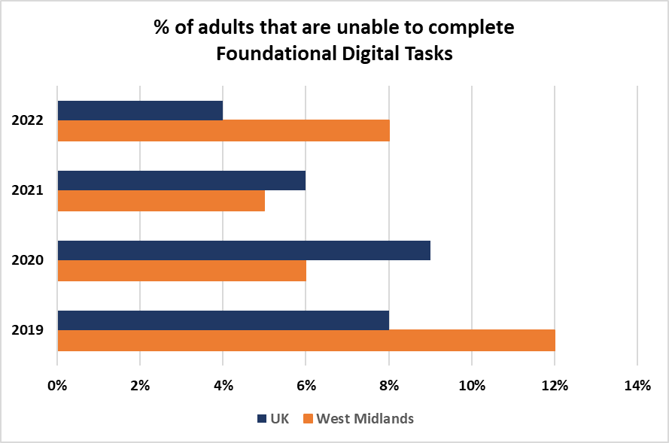

**Figure 1: % of adults that are unable to complete foundational digital task (West Midlands and UK)**

The foundational tasks that are listed in table 3 shows the region performing poorer on all but one of the foundational tasks in the period 2021 to 2022. The largest fall was seen in the proportion of adults that can use the available controls devices, this fell by 6 percentage points year on year and helps to explain the rise in the region’s digital exclusion statistics in the last year.

|  |  |  |  |
| --- | --- | --- | --- |
| Foundational Tasks | 2021 | 2022 | % change 2021-22 |
| * I can turn on the device and enter any account login information as required | 91% | 88% | -3% |
| * I can use the available controls on my device (e.g. mouse, keyboard, touchscreen, trackpad) | 94% | 88% | -6% |
| * I can use the different settings on my device to make it easier to use (e.g. adjust font size, volume settings, brightness of screen, voice activation or screen readers) | 88% | 86% | -2% |
| * I can find and open different applications/programmes/platforms on my devices (e.g. opening a web browser, messaging applications) | 87% | 88% | 1% |
| * I can set up a connection to a Wi-Fi network on my devices (e.g. when at home, work, out in public or visiting family and friends) | 87% | 85% | -2% |
| * I can open an Internet browser to find and use websites (e.g. Safari, Google Chrome, Mozilla Firefox, Microsoft Edge) | 91% | 88% | -3% |
| * I can keep my login information and passwords for a device and any accounts secure (e.g. not shared with anyone or written down or left prominently near a device) | Not included | 88% | N/A |
| * I can update and change my password when prompted to do so | 89% | 86% | -3% |

**Table 3: Digital Inclusion Foundational Tasks**

## Sharing and using data to improve people’s lives

Mission 2 is designed to utilise data in the most effective ways to improve people’s lives and seeks to achieve three aspirations:

* Data is shared effectively across organisations to solve key regional challenges.
* The West Midlands are national leaders on data ethics, open data, and data security.
* Advanced data analytic methods are regularly used to improve public services and grow our economy.

Data sharing across the public sector is an important aspect of driving innovation, improving public services and informing decision making[19]. This is a driving factor behind mission 2 with the WMCA seeking to improve how data is shared, analysed and used across the region.

**Strength and opportunities**

Literature reviewed for this report suggests that there are many benefits to collecting, using and sharing data, with most of these benefits being aligned to all five roadmap mission areas. Analysis in the National Data Strategy (NDS)[20] helps to demonstrate this, highlighting what it calls “*five concrete and significant opportunities for data to positively transform the UK*”:

1. **Boosting productivity and trade -** the UK exports £190bn in digitally delivered services (67% of total UK services exports).
2. **Supporting new businesses and jobs -** there was over a 50% increase in data professionals between 2013 and 2020 - increasing from 1.1m to 1.7m employees.
3. **Increasing the speed, efficiency and scope of scientific research -** more advanced applications of data-driven technology have also provided responses to the coronavirus pandemic.
4. **Driving better delivery of policy and public services -** the NHS, tax and the courts each engaging with millions of people across the UK every year.
5. **Creating a fairer society for all -** civil society organisations can be better equipped to reach the people most in need, at the time they most need it.

Other analysis such as that by the EU Parliament suggests that using and sharing data helps to drive innovation (i.e. supporting companies to develop and improve products, thus contributing to mission 4 aspirations). It is said that the use of data also has environmental benefits by helping to reduce carbon emissions “*by mitigating traffic jams and optimising the energy efficiency of buildings and cars*”[21]. The Local Government Association also cites key benefits, explaining that data can lead to better service design, drive and help local authorities be transparent and publicly accountable. Government commissioned analysis[22] also discusses the accountability point and outlines how making data available to the public can enable public trust in organisations, which is a regional aspiration.

**Challenges**

The evidence reviewed shows that there are also many challenges associated with data sharing, ethics and analysis. The NDS is a useful source in considering these challenges because it was collated through a consultation with UK stakeholders, which includes public sector organisations like the seven Met Local Authorities and the WMCA. The challenges outlined in the report can also be aligned to the mission 2 aspiration to help policy leads further understand the barriers for the regional data ecosystem.

**Data is shared effectively across organisations to solve key regional challenges:**

* A lack of resources for local authorities to deal with data issues.
* Inconsistent formatting of public sector data.
* The pace of change leads to a fragmentation in the systems used to manage data, with ongoing resourcing issues linked to set up and maintenance costs.

**The West Midlands are national leaders** **on data ethics, open data, and data security.**

* A lack of senior buy-in and leadership on data.
* A lack of alignment across government.
* Privacy and security concerns.

**Advanced data analytic methods are regularly used to improve public services and grow our economy:**

* Market barriers to greater re-use, including data hoarding and differential market power.
* A lack of skills in managing data.

In addition to these challenges, the Department for Science, Innovation and Technology (DSIT) analysis of regional digital ecosystems[23] highlighted one cross cutting challenge for data sharing which it classifies as a barrier to growth for the Roadmap, it states “limited cross-regional governance constrains shared progress on digital challenges, *particularly around data sharing, digital inclusion, and basic digital infrastructure*”. This is a key issue that needs to be addressed as part of the Digital Roadmap Programme in the next three years. The WMCA will need to consider how it can build and improve on former governance structures such as the Digital Skills Partnership (DSP) which acted in an advisory capacity to the WMCA on digital skills. It should be noted that DSIT specifically referenced the DSP as being key to achieving prosperity.

**Scale of the Challenge**

The Scale of the Challenges analysis for mission 2 uses four indicators to help policy leads further understand the landscape for data sharing and use in the region. All four indicators are from the UK Business Data Survey[24] and feature in Tech UK’s Local Capital Index report:

* Data Acquisition - % of businesses ‘acquires or collects any data
* Data Availability - % of businesses that say that data from outside their business has become more readily available in the last ten years.
* Data Sharing - % of businesses that shares data
* Data Recipients - % of businesses that receive personal data from ‘public bodies’ and charities

The data shows the West Midlands is ahead of the national average on the data acquisition KPI at 34%, 5pp above the regional average and acquisition 16pp above the worst performing region. 17% of businesses in the region share data, which is 1pp above the national average and 4pp below the best performing region at 21%. Tech UK’s analysis measures data availability, which is the % of businesses that say that data from outside their business has become more readily available in the last ten years. On this metric the region average is 53%, 1pp below the national average. Tech UK analyses data recipients, which is the % of businesses that receive personal data from ‘public bodies’ and charities, here the region has a 2pp gap with the national average (24% vs 22%).

|  |  |  |  |  |
| --- | --- | --- | --- | --- |
| Scale of the Challenge: Sharing and using data to improve people’s lives | | | | |
| Indicator | **National Avg.** | **West Mids Avg.** | **Gap to Nat Avg.** | **Linked Roadmap Aspirations** |
| Data Acquisition - % of businesses ‘acquires or collects any data’ | 29% | 34% | 4,982 (+5pp) more businesses in the region collect data than the nat avg. | * Data is shared effectively across organisations to solve key regional challenges. |
| Data Availability - % of businesses that say that data from outside their business has become more readily available in the last ten years. | 54% | 53% | 467 (+1pp) more businesses needed to reach nat avg. |
| Data Sharing - % of businesses that shares data | 16% | 17% | 701 (+1pp) more businesses in the region share data compared to the nat avg. |
| Data Recipients - % of businesses that receive personal data from ‘public bodies’ and charities | 24% | 22% | 1,479 (+2pp) more businesses needed to reach the nat avg. | * Advanced data analytic methods are regularly used to improve public services and grow our economy. * The West Midlands are national leaders on data ethics, open data, and data security. |

**Table 4: Scale of the Challenge – Mission 2**

## Becoming the best connected region

The third Digital Roadmap mission is about how the West Midlands can become the best connected region nationally. The three connectivity aspirations are:

* Best 5G mobile coverage of any CA region – with at least 40% population coverage by 2025.
* Best 4G mobile coverage of any CA region – with >95% outdoor and >90% indoor coverage.
* Highest gigabit broadband access with the region achieving its fair share of full fibre broadband investment versus other large urban conurbations to fibre by 2025 and best fibre access in deprived areas.

**Strengths and opportunities**

Connectivity, like data is a key enabler of much of the other strengths and opportunities across the Roadmap programme. For example, access to fast and reliable fixed and mobile connectivity and the skills and ability to use it, is a critical prerequisite for the region to take advantage of the digital economy. Deloitte and DSIT estimate that adoption of connectivity technologies typically adds 1-2% GDP based-on historic studies and according to a study by Barclays, 5G has the potential to boost the Midlands economy by up to £1.9bn additional business revenue by 2025[25]. Furthermore, DSIT’s (24) analysis states that the region *“well-regarded infrastructure for digital and associated tech incubators and workspaces, including Innovation Birmingham, WeWork and STEAMhouse and Spark Wolverhampton”*, all of which are powered by good connectivity, with the latest Ofcom data showing that gigabit capable coverage is strong, with almost 88% of all premises having access[26].

The Local Capital Index shows that the region is continuing to improve its infrastructure which is being driven by improvements in connectivity. The Index ranks the region 6th (up from 7th in 2022) of 41 areas based on Superfast Broadband availability, Ultra-Fast Broadband availability, gigabit availability, 4G coverage and 5G coverage. This is also important to note for the region’s work on digital inclusion, in particular the opportunity to increase broadband usage through household usage of social tariffs.

**Challenges**

There are key connectivity challenges that stakeholders need to consider for the next iteration of the Roadmap. They relate to varying levels of connectivity in the region and the cost of infrastructure. On access, data analysis shows that there are significant inter-regional connectivity gaps. Ofcom data shows that full fibre broadband connectivity is poor in the Black Country; at 36% in Sandwell, 25% in Walsall, and less than 7% in Dudley, all below the regional average of 43% (24). This is concerning given the high levels of deprivation across many of the neighbourhoods in these local authority areas. On costs, policy leads will need to consider the cost of rolling out new connectivity technologies, which can be prohibitively expensive for the private sector. For example, WM5G estimates that it will require operators to invest £2-3bn to rollout 5G across the region – with no guarantee of a commercial return.

**Scale of the Challenge**

The Scale of the Challenge analysis for connectivity uses four indicators to further contextualize the strengths and opportunities and challenges discussed. All four indicators are from the Ofcom connected nations dataset:

* 5G Geographic Coverage %
* 4G Geographic Coverage %
* % of all premises that are full fibre capable
* % of all premises that are gigabit capable

Table 5 shows how these indicators are aligned to the Roadmap aspirations and how the region currently compares to the national picture. The analysis shows that the region is ahead of the national average on all four indicators. This performance is unsurprising given that much of the country is rural, as a result the analysis uses GMCA as a comparator area on connectivity to more accurately to benchmark where the region is in terms of connectivity.

|  |  |  |  |  |
| --- | --- | --- | --- | --- |
| Scale of the Challenge: Becoming the UK’s best-connected region | | | | |
| Indicator | **National Avg.** | **West Mids Avg.** | **Gap to Nat Avg.** | **Linked Roadmap Aspirations** |
| 5G Geographic Coverage % | GMCA (53%)  Eng. (45%) | 65% | +12pp above GMCA  +20pp above Eng. | * Best 5G mobile coverage of any CA region – with at least 40% population coverage by 2025. |
| 4G Geographic Coverage % | GMCA (97%)  Eng. (70%) | 99% | +2pp above GMCA.  +29% above Eng. | * Best 4G mobile coverage of any CA region – with >95% outdoor and >90% indoor coverage. |
| % of all premises that are full fibre capable | GMCA (34%)  Eng. (40%) | 43% | +9pp above GMCA  +3pp above Eng. | * Highest gigabit broadband access with the region achieving its fair share of full fibre broadband investment versus other large urban conurbations. |
| % of all premises that are gigabit capable | GMCA (78%)  Eng. (40%) | 88% | +10pp above GMCA.  +48pp above Eng. |

**Table 5: Scale of the Challenge – Mission 3**

The data shows that the WMCA also performs better than the GMCA on the four measures included, with the largest gap being on 5G coverage. The latest data shows that the region has the best 5G coverage of any Combined Authority area nationally. The region’s coverage was in line with other Combined Authority areas in 2021, but since then coverage has increased by 23pp to 65%. This now means that the region’s coverage is twice as good as Cambridgeshire and 12pp above Greater Manchester which is the second best performing area. This is a key measure for mission 3 given that the basis of the mission is the region becoming the best connected nationally. This performance is one of the key drivers of the region’s performance on the 2023 Local Capital Index.

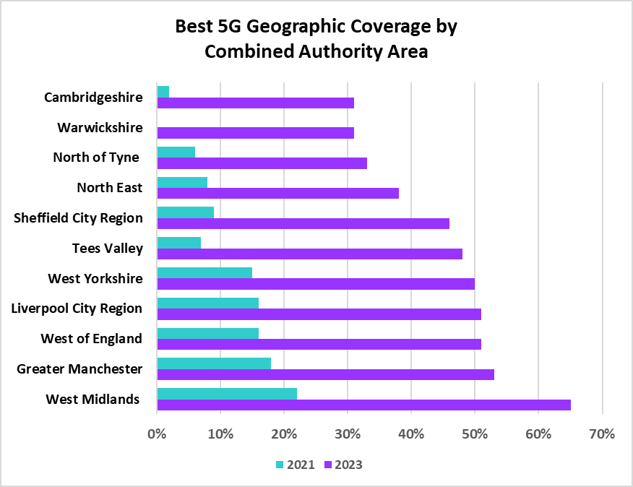

**Figure 2: 5G Connection across Combined Authority Areas**

## Realising the potential of digital to transform our economy and build economic resilience

Mission 4 is about using business support and digital technologies to transform the economy and build economic resiliency, the three economy aspirations are:

* All SMEs and micro business adopt basic digital technologies to boost output and productivity.
* Firms across the regional economy adopt advanced digital technologies (e.g. AI, blockchain, VR/AR, 5G, IoT).
* Tech and digital firms that are looking to scale up can access support and finance in the region.

The UK’s Digital Strategy outlines the importance of digital to the national economy, highlighting the impact on economic growth and job creation, noting that the UK data economy has the biggest overall impact of any EU country in absolute terms, an estimated near £125bn in 2021 and that a new tech business launched in the UK every half an hour throughout 2020 (1).

**Strengths and opportunities**

One of the main strengths and opportunities for the region to consider is the size of the region’s Tech economy, which according to UKTN is worth £15.3bn, with 2,400 businesses employing 144,000 people (4). The latest Local Capital Index report estimates that the wider region ranks 5th out of 12 areas on Digital GVA per person. International trade in digital services as a percentage of regional GVA is also good at 1.4% and is in the upper quartile (24).

DSIT’s analysis notes that there is clear success in attracting and retaining large digital economy employers – citing HSBC (UK headquarters), Goldman Sachs (Northern Office), Deutsche Bank and Lombard Risk (new Technology Centre), The digital economy is increasingly multi-centred in its distribution (outside of Birmingham), with already strong nodes of digital sector employment around, for example, Leamington Spa (Gaming), Worcester, Warwick (linking with the subregion’s expertise in Advanced Manufacturing), and Nuneaton.

The region is also promoting three Hight Potential Opportunities; Birmingham and Solihull (Data Driven Healthcare and Technologies), Coventry and Warwickshire (Connected and autonomous vehicle modelling and simulation – with the automotive sector is forecasted to grow by 16% in the next four years and 25% of the UK’s aerospace industry is in the region), and Leamington Silicon Spa (Gaming 25% of the UK’s games output and the 2nd largest cohort of computer science students in the UK). 85% of technology decision makers say West Midlands is currently a good place to start and grow a technology business (24). Furthermore, 79% of decision makers in the region’s tech companies believe the West Midlands tech scene will grow rapidly in the next five years.

The scale and growth prospects of the region will also be driven by the scale of activities and demand for services across key sectors in the coming years. The scale of the regions key clusters and sectors are highlighted below:

* WMCA Plan for Growth Clusters –targeted interventions in the eight primary clusters are expected to deliver additional GVA in the West Midlands of between £2.9bn and £3.2bn. These interventions could raise the West Midlands growth rate above the UK average. Delivering between 40,300 and 44,800 additional jobs. Much of the growth will be digital driven.
* Advanced Manufacturing – manufacturing generates £16bn and there are £32,500 students doing STEM subjects in the region.
* Life Sciences - 61% of the region’s healthcare sector is in Medtech, 8% of the UK’s overall turnover in the field. Healthcare, MedTech and Data-Driven Health economies in the UK, employing over 17,000 dedicated professionals.
* Low Carbon (including energy) - £12bn is generated from the sector in the region. The West Midlands’ low carbon and environmental goods sector employs 94,000 people 20,000 new jobs are projected in the next five years.
* Business and Professional Services (BPFS) – the region has one of the largest and fastest-growing BPFS clusters with 48,400 companies employing 343,000 people and counting. Finance Tech is a key part of this sector and is currently worth over £400m, employs over 7,000 specialists, and generates more than 6% of the UK’s entire FinTech GVA.

A key facet in supporting the growth of the region’s business base is the adoption of technology due to the impact on productivity and growth. Analysis by the Office for National Statistics (ONS) finds that SMEs that the use of two or more business management technologies can experience productivity gains of up to 25%[27]. The sector is also worth £5bn across the region and £1.5bn in Birmingham alone. Businesses are being supported to innovate through initiatives like the Made Smarter Programme to help manufacturing and engineering SMEs utilise new digital technologies such as AI, advanced robotics, big data and wearable technology to improve their efficiency and productivity[28]. Analysis in the Local Capital Index shows that the region is making progress on adoption ranking the West Midlands 22 out of 41 areas on digital adoption (classified by the number of digital occupations, digital employment share, business investment in ICT and the number of digital businesses) for 2023, up two places from 24th in 2022.

AI represents a growing opportunity for the region, with Midlands Engine commissioned[29] analysis showing that there are 300 AI businesses in the region (11% of the national total). This represents a 122% growth in the last 10 years. The analysis also shows that the wider regional universities are developing solutions to real world problems having received close to £20m in AI funding since 2017.

The business support and wider innovation ecosystem also presents an opportunity for the West Midlands. On the former, the West Midlands region now has a new business support initiative Business Growth West Midlands which will lead on supporting firms to grow and this will include supporting firms to adopt technologies. Innovate UK also published its West Midlands Local Action Plan[30]) earlier this year and this detailed strategic opportunities such as exploring co-investment opportunities (in line with the WMCA’s own announcement on a co-investment fund to support SMEs to grow[31]) and other work that will help enhanced the opportunities outlined in this report.

Cyber is also another area that represents a key opportunity for the region, with Cyber representing 8% of the UK’s total employment and business base. It should also be noted that the Universities of Birmingham and Warwick are both accredited by the UK's National Cyber Security Centre. This is an area that should be explored in more detail by the WMCA and its partners.

**Challenges**

There are several key challenges related to business support (finance and advice) and productivity and growth of the region’s business base. On the business base, data used in the latest Local Capital Index shows that the region needs 115 more high growth businesses to be in line with the national average.

On finance, the Local Capital Index specifically references the need for additional financial support for businesses in the region *“the West Midlands CA area should look to improve finance and investment coming into the region, especially VC funding*”. Furthermore, Midlands Engine analysis does highlight Artificial Intelligence as an opportunity but notes that “*while £39m worth of investment has gone into the Midlands, AI companies in the region are underfunded in comparison to the rest of the UK”.* Furthermore, work commissioned through Tech West Midlands further highlights the need for a strong business support offer, by highlighting four key challenges for mission 4:

* **A fragmented ecosystem** – collaboration happens in silos and not around key strategic initiatives and projects. Additionally, the ecosystem is fragmented which is preventing people and organisations from finding the right information at the right time, which inhibits growth in tech.
* **Poor access to high growth support** – regional tech firms require better access to funding and investment and better way to digest information.
* **A lack of purpose** – there is a need for a unified purpose, something that the tech ecosystem can get behind and support.
* **Limited visibility and need for stronger narrative** – the region needs a strong narrative, brand and messaging to develop an identity to for the region’s tech system.

The recently published Tech Tonic report[32] by the Federation of Small Businessfurther outlines these challenges related to business support and finance:



**Figure 3: FSB Innovation Survey Barriers to Growth**

**Scale of the Challenge**

Additional digital economy related KPIs are reviewed in table 6 to further demonstrate the scale of the challenge for the region, they are:

* Digital businesses as a % of business births[33];
* Digital businesses as a % of business deaths (33)
* GVA contribution of digital business as % of total business base[34]
* Business investment in ICT[35].

|  |  |  |  |  |
| --- | --- | --- | --- | --- |
| Scale of the Challenge: Realising the potential of digital to transform our economy and build economic resilience | | | | |
| Indicator | **National Avg.** | **West Mids Avg.** | **Gap to Nat Avg.** | **Linked Roadmap Aspirations** |
| Digital businesses as a % of business births | 8.2% | 4.6% | An additional 1,314 (+3.6pp) digital business births needed to meet the nat avg. | * Tech and digital firms that are looking to scale up can access support and finance in the region. * Firms across the regional economy adopt advanced digital technologies (e.g. AI, blockchain, VR/AR, 5G, IoT). * All SMEs and micro business adopt basic digital technologies to boost output and productivity. |
| Digital businesses as a % of business deaths | 8.4% | 5.9% | There are 675 (2.5pp) fewer business deaths in the region compared to nat avg. |
| Business investment in ICT | 6.45% | 6.27% | Proportionately, the total digital business base invest £22m (0.18pp) less in ICT compared to the nat avg. |
| Total R&D spending by all sectors | £940m | £1.2bn | +£260m more R&D spend in region compared to the nat avg. |

**Table 6: Scale of the Challenge – Mission 4**

The latest business births and business deaths data shows a mixed picture for the region. In total 4.6% of the region’s business births a digital businesses, this is 3.6pp below the national average and an additional 1,314 businesses are needed to be in line with the national average. DSIT’s Assessing the UK’s Regional Digital Ecosystems does describe the wider regional higher growth digital business base as being underdeveloped and this seen as a barrier to growth. However, the latest business deaths analysis is positive and shows that the region performs better than the national average by 2.5pp, 675 above the national average.

Another KPI used for the Scale of the Challenge analysis (as a measure of adoption) for Mission 4 is investment in ICT by West Midlands firms. This type of investment is a key driver of growth and techUK’s Local Digital Index cites ICT investment as a key metric for adoption, which links to all SMEs and micro business adopt basic digital technologies to boost output and productivity Mission 4 Roadmap aspirations. The latest data shows regional companies invest c£758m in ICT which means the region would need an additional £22m more worth of investments in ICT to be in line with the national average. The regional figure was above the national average in 2017, but has been below the national average since then.

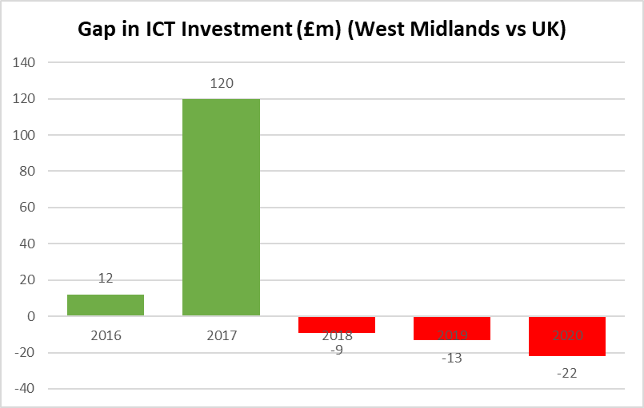

**Figure 4: Digital Sector GVA gap with national average (WMCA)**

A positive finding from the data reviewed is that the region spends £260m more on R&D than the national average.

## Using digital public services to build a fairer, greener, healthier region

Mission 5 of the Roadmap aims to improve people's lives and the environment using digital public services, they are three aspirations:

* Regional carbon reduction as outlined in the WM2041 net zero strategy.
* Reduction in the health inequalities by ensuring that vulnerable adults and those with multiple and complex needs are provided humancentred support to improve their wellbeing.
* The WMCA and other regional organisations should work to increase citizen engagement via digital portals and platforms.

These goals are designed because of the recognition that the technological adoption is impacting all aspects of life, including how people access the public services that are the most important to them. Research by Ernst and Young[36] shows how the coronavirus pandemic helped to escalate the use of digital public services because of the inability of people to physically move around as they did prior to the pandemic. The firm’s analysis suggests that there is scope in the UK to improve the public’s perception of the effectiveness of digital public services with 39% of UK residents thinking the use of technology was effective, compared to 53% globally.

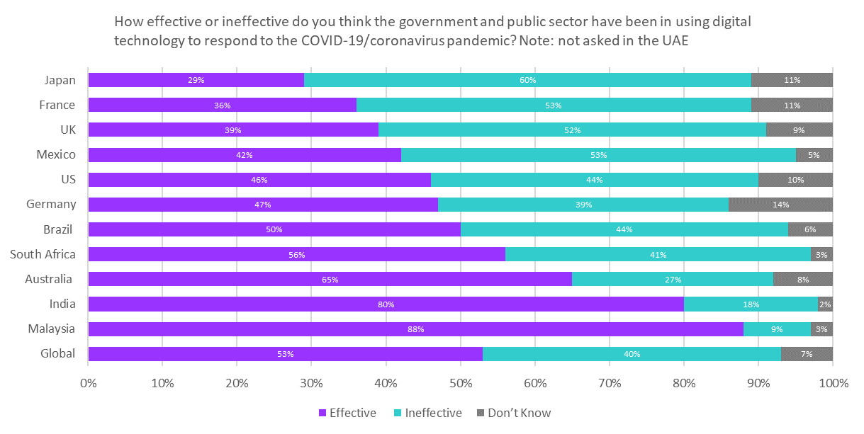

**Figure 5: Digital public services effectiveness (UK vs other countries)**

**Strengths and Opportunities**

There are several key benefits to improving services for Government, other public organisations and the public, these benefits include[37]:

* **Saving time** - businesses and citizens spend 50% less time interacting with public services. Public administration could save 6 of every 10 hours of processing time for service transactions.
* **Costs** - with the potential for businesses save money on front line services.
* **Trusts** - Citizens who are satisfied with public services are 9 times more likely to trust their government.

Another opportunity for stakeholders to consider is how the use and implementation of digital public services are aligned to wider societal aims. For example, the drive to improve health and wellbeing and achieve net-zero carbon emissions is shaping technological developments globally. Analysis by Accenture and the World Economic Forum states that the adoption of digital technologies could help industry reduce carbon emissions by 4-10%[38]. This alignment to wider societal aims also presents potential economic opportunities through the demand for services. In considering mission 5 goals these opportunities could relate to the demand and supply across four key areas in particular:

* **Health** – an aging population is helping to drive demand for digital healthcare technology[39]
* **Energy** – opportunities to inform the public and industry is driving the increasing use of digital twins[40]
* **Environment** – there will be demand for cleaner technologies to help the region its 2041 aims, this is likely to create employment and growth opportunities for businesses in the region and it should be noted that low carbon or ‘Clean Tech’ is the only sector in which the WMCA geography has a higher GVA per employee than the UK[41]
* **Transport** – Transport for West Midlands supports residents to plan their public transport journeys, this in turn supports carbon reduction and employment in public transport[42]

**Challenges**

There are several key challenges that could impede progress for mission 5. These challenges can be viewed in terms of demand (the ability to access and use public services) and supply (the ability of and speed at which government and industry can deliver them.

On demand, digital exclusion analysis conducted above suggests that accessing and using digital public services is challenging for many in the West Midlands region. The Local Capital Index includes a measure on public services, it is measured on “*the percentage of the population who access local or national government services online, e.g., to find information, complete processes such as tax returns or to contact a local* *MP*”. The data shows that 47% of people in the region are accessing these services online, below the national average of 50% and 14pp below London which is the best performing region. This finding helps to further emphasize the digital exclusion challenge in the region.

Many of the supply side challenges are related to those discussed under mission 3, for example the ability of firms to access the finance and business support needed to progress their work on adoption. Policy leads will need to consider those challenges as they pertain to mission 5 also.

**Scale of the Challenge**

This report considers four key metrics that focus on the confidence and ability of residents to access digital public services, they are

* Digital Propensity Score (how confident households are using government online resources)[43];
* Percentage of adult population who has accessed public services online (24).
* % of census returns made online[44]
* % of patients that are able to book/cancel appointments online[45].

The data shows that there is a gap between the West Midlands and national averages on all four measures. Proportionally fewer health appointments are booked online in the region compared to the national average, despite a slightly higher proportion of GPs offering an online facility in the region – 95% vs 93%. The data also helps to further demonstrate digital poverty in the region, given the gap in the proportion of non/limited internet users in the region.

|  |  |  |  |  |  |
| --- | --- | --- | --- | --- | --- |
| Digital Roadmap Scale of the Challenge | | | | | |
| Theme | **Indicator** | **National Avg.** | **West Mids Avg.** | **Gap to Nat Avg.** | **Linked Roadmap Aspirations** |
| Mission 5: Using digital public services to build  a fairer, greener, healthier region | Digital Propensity Score (how confident households are using government online resources) | 93.9% | 93.3% | Proportionally, 6,513 (0.6pp) households in the region are less confident than the nat  avg. | * Regional carbon reduction as outlined in the WM2041 net zero strategy. * Reduction in the health inequalities by ensuring that vulnerable adults and those with multiple and complex needs are provided humancentred support to improve their wellbeing. * The WMCA and other regional organisations should work to increase citizen engagement via digital portals and platforms. |
| Percentage of adult population who has accessed public services online. | 47% | 50% | An additional 68,974 people need to access public services online be in line with the nat avg. |
| % of census returns made online | 88.6% | 82.1% | Proportionately 77,321 (6.5pp) fewer households in the region returned census online. |
| % of patients that are able to book/cancel appointments online | 43.6% | 43% | An additional 13,795 (0.6pp) patients need to access appointments online to be on part with the nat avg. |

**Table 7: Scale of the Challenge – Mission 5**

# Inclusive Growth Fundamentals

This section outlines how all the Roadmap related aspirations and Scale of the Challenge indicators aligns with the WMCA’s Inclusive Growth Fundamentals. Doing this will help policy leads understand how roadmap activities will help the region to achieve its inclusive growth aims.

|  |  |  |
| --- | --- | --- |
| Digital Roadmap Missions | Digital Roadmap Aspirations | Inclusive Growth Fundamentals |
| * Securing access for everyone to digital opportunities, particularly those in poverty | * Everyone has access to an affordable device and connection, and feels confident to access the internet and basic services. | * Affordable and safe spaces |
| * Everyone can access digital jobs, particularly young people and those at risk of redundancy. | * Equality |
| * The supply of digital skills meets demand. | * Education and Learning |
| * Sharing and using data to improve people’s lives | * Data is shared effectively across organisations to solve key regional challenges. * The West Midlands are national leaders on data ethics, open data, and data security. * Advanced data analytic methods are regularly used to improve public services and grow our economy. | * Power and Participation |
| * Becoming the UK’s Best-Connected Region | * Best 5G mobile coverage in UK - with at least 40% population coverage by 2025. * Best 4G mobile coverage in UK – with >95% outdoor and >90% indoor coverage. * Highest gigabit broadband access with the region achieving its fair share of full fibre broadband investment versus other large urban conurbations | * Connected Communities |
| * Realising the potential of digital to transform our economy and build economic resilience | * All SMEs and micro business adopt basic digital technologies to boost output and productivity. * Firms across the regional economy adopt advanced digital technologies (e.g. AI, blockchain, VR/AR, 5G, IoT). * Tech and digital firms that are looking to scale up can access support and finance in the region. | * Inclusive Economy |
| * Using digital public services to build a fairer, greener, healthier region | * Regional carbon reduction as outlined in the WM2041 net zero strategy. | * ClimateResilience |
| * Reduction in the health inequalities by ensuring that vulnerable adults and those with multiple and complex needs are provided humancentred support to improve their wellbeing. * The WMCA and other regional organisations should work to increase citizen engagement via digital portals and platforms. | * Health and Wellbeing |

# Conclusion

This evidence report analysis shows that the region has great growth prospects and specialisms but there are also barriers that are impeding progress. Many of these barriers are related to long term inequality and deprivation, for example there is unsurprisingly a cross over between the neighborhoods that have higher levels of deprivation and digital exclusion and the region is one of the poorest performing areas for formal qualifications which helps to contextualize the challenges around digital skills. The region does also have many strengths and opportunities as discussed and the call from DSIT for better data sharing could help to support the region to harness those benefits further.

It is recommended that this report is circulated to the relevant WMCA forums for debate and to support stakeholders to decide on the activities that will be included in the Digital Roadmap (2024-2027).

1. [Gov.uk](https://www.gov.uk/government/publications/uks-digital-strategy)
2. [Amazon.co.uk](https://www.aboutamazon.co.uk/news/aws/digital-transformation-could-grow-the-uk-economy-by-over-413-billion-by-2030)
3. [Amazon.co.uk](https://www.aboutamazon.co.uk/news/aws/digital-skills-drive-gains-for-individuals-organisations-and-the-uk-economy)
4. [UKtech.news](https://www.uktech.news/regional-tech-report-west-midlands-1)
5. [WMCA.org.uk](https://www.wmca.org.uk/documents/productivity-skills/west-midlands-digital-roadmap/)
6. [WMCA.org.uk](https://www.wmca.org.uk/what-we-do/economy-and-innovation/plan-for-growth/)
7. [Gov.uk](https://www.gov.scot/publications/scotlands-digital-strategy-evidence-discussion-paper/documents/)
8. [Un.org](https://www.un.org/en/un75/impact-digital-technologies) 
9. [Goodthingsfoundation.org.uk](https://www.goodthingsfoundation.org/insights/the-economic-impact-of-digital-inclusion-in-the-uk/)
10. [Fenews.co.uk](https://www.fenews.co.uk/exclusive/social-mobility-how-can-the-tech-sector-support-young-people/)
11. [Goodthingsfoundation.org.uk](https://www.goodthingsfoundation.org/insights/the-economic-impact-of-digital-inclusion-in-the-uk/)
12. [WMCA.org.uk](https://www.wmca.org.uk/media/5423/wmca-adult-education-budget-2022-2025-strategya6ab43e0bfce22820d3180bc2104a098bd3e1d03702673a69bf4fae4ee6f53f1.pdf)
13. Centreforsocialjustice.org
14. <https://digitalpovertyalliance.org/>
15. WM5G, Addressing the digital divide in the West Midlands through raising awareness of social tariffs
16. [TechUK.org](https://www.techuk.org/shaping-policy/nations-and-regions-hub/local-digital-capital-index-2023.html)
17. <https://www.lloydsbank.com/banking-with-us/whats-happening/consumer-digital-index.html>
18. [nomisweb.co.uk](https://www.nomisweb.co.uk/query/select/getdatasetbytheme.asp?theme=27) 
19. [Parliament.uk](https://post.parliament.uk/research-briefings/post-pn-0664/)
20. [Gov.uk](https://www.gov.uk/guidance/national-data-strategy)
21. [Europarl.europa.eu](https://www.europarl.europa.eu/news/en/headlines/society/20220331STO26411/boosting-data-sharing-in-the-eu-what-are-the-benefits)
22. [Gov.uk](https://www.gov.uk/government/publications/cdei-publishes-its-first-report-on-public-sector-data-sharing/addressing-trust-in-public-sector-data-use)
23. [Gov.uk](https://www.gov.uk/government/publications/assessing-the-uks-regional-digital-ecosystems)
24. [Gov.uk](https://www.gov.uk/government/statistics/uk-business-data-survey-2022/uk-business-data-survey-2022--2)
25. [Barclayscorporate.com](https://www.barclayscorporate.com/content/dam/barclayscorporate-com/documents/insights/innovation/5g-a-transformative-technology.pdf)
26. [Ofcom.org](https://www.ofcom.org.uk/research-and-data/multi-sector-research/infrastructure-research)
27. [ONS.gov.uk](https://www.ons.gov.uk/economy/economicoutputandproductivity/productivitymeasures/articles/informationandcommunicationtechnologyintensityandproductivity/2018-10-05)
28. [Madesmarter.co.uk](https://www.madesmarter.uk/resources/blog-how-made-smarter-can-support-the-west-midlands/#:~:text=How%20Made%20Smarter%20can%20support%20the%20West%20Midlands&text=The%20%C2%A31.9%20million%20Made,improve%20their%20efficiency%20and%20productivity.)
29. [MIdlandsengine.org](https://midlandsengine.org/news-events/ai-and-the-exceptional-scale-of-opportunity-in-the-midlands-new-cluster-report-published/)
30. [iuk.ktn-uk.org](https://iuk.ktn-uk.org/wp-content/uploads/2023/07/Innovate-UK_West-Midlands-Action-Plan_PW_AW2-Digital.pdf)
31. [WMCA.org.uk](https://www.wmca.org.uk/news/pioneering-25-million-investment-fund-launched-to-help-grow-region-s-industries-of-the-future/)
32. [fsb.org.uk](https://www.fsb.org.uk/resource-report/the-tech-tonic.html)
33. [ONS.gov.uk](https://www.ons.gov.uk/businessindustryandtrade/business/activitysizeandlocation/bulletins/businessdemography/2021#:~:text=Both%20business%20birth%20and%20death,in%202021%20than%20in%202020.)
34. Total R&D spending by all sectors (Government, Higher Education, Businesses, Non-profits), ONS.
35. [ONS.gov.uk](https://www.ons.gov.uk/economy/regionalaccounts/grossdisposablehouseholdincome/articles/experimentalregionalgrossfixedcapitalformationgfcfestimatesbyassettype1997to2020/2022-05-10)
36. [www.ey.com](https://www.ey.com/en_uk/government-public-sector/how-can-digital-government-connect-citizens-without-leaving-the-disconnected-behind)
37. [Mckinsey.com](https://www.mckinsey.com/industries/public-sector/our-insights/digital-public-services-how-to-achieve-fast-transformation-at-scale)
38. <https://www.weforum.org/agenda/2022/05/how-digital-solutions-can-reduce-global-emissions/>
39. [Mckinsey.com](https://www.mckinsey.com/industries/life-sciences/our-insights/healthtech-in-the-fast-lane-what-is-fueling-investor-excitement)
40. [Bernardmarr.com](https://bernardmarr.com/how-are-digital-twins-used-in-practice-5-real-world-examples-beyond-manufacturing/)
41. [WMCA.org.uk](https://www.wmca.org.uk/what-we-do/economy-and-innovation/west-midlands-innovation/cleantech-challenges-and-opportunities/)
42. <https://www.tfwm.org.uk/>
43. [ONS.gov.uk](https://www.ons.gov.uk/peoplepopulationandcommunity/householdcharacteristics/homeinternetandsocialmediausage/articles/digitalpropensityindexforenglandandwaleslsoas/census2021#:~:text=The%20DPI%2C%20a%20measure%20of,used%20in%20planning%20Census%202021.)
44. [ONS.gov.uk](https://www.ons.gov.uk/peoplepopulationandcommunity/householdcharacteristics/homeinternetandsocialmediausage/datasets/census2021onlineshareofhouseholdresponsesbylowerlayersuperoutputareaforenglandandwales)
45. [Digital.nhs.uk](https://digital.nhs.uk/data-and-information/publications/statistical/mi-patient-online-pomi/current)